PEARSON EDEXCEL BTEC LEVEL 3 EXTENDED CERTIFICATE IN SPORT (360 GLH)

Bridging Unit 2020

Contacts:

Head of Physical Education– Mr Kyle
rkyle@stj.kent.sch.uk

Teacher of Unit 1 – Mrs Weller
lweller697@stj.kent.sch.uk

Teacher of Unit 2 – Miss Munns or Miss Thomson
kmunns882@stj.kent.sch.uk
hthomson@stj.kent.sch.uk

Teacher of Unit 3 – Miss Munns
kmunns882@stj.kent.sch.uk

Teacher of Unit 4 – Mr Dale
sdale@stj.kent.sch.uk

Introduction

This series of tasks and activities are designed to give you an insight into the Pearson EDEXCEL BTEC Level 3 Extended Certificate in Sport course. As part of the transition from year 11 Level 1/2 BTEC Sport to Level 3 BTEC Sport it is important to develop a greater understanding of certain aspects of the course which will help you over the next two years. Please complete the following booklet.

Name

School

Do you play sport?

If yes to the question above;
Team & League/Competitions

Other commitments e.g. part time jobs/gym membership

This booklet has been prepared by the PE Department for you to read and the work contained in it will ensure that you get off to a positive start in this subject area. It is very important that you read this booklet carefully over the summer and attempt to complete the work to the best of your ability and submit it to your teacher. This will be the first impression you create and is a real indicator of how seriously you are prepared to be in your studies.

COURSE OUTLINE

Eligibility for awards;

In ordered to awarded a qualification a learner must complete all units and achieve a pass or above in all mandatory units.

To achieve any qualifications grade, learners must;
1. Complete and have an outcome (D, M P and U) for all units with a valid combination.

2. Achieve the required units at pass or above and for the Extended Certificate achieve a minimum of 360 GLH at a pass or above.
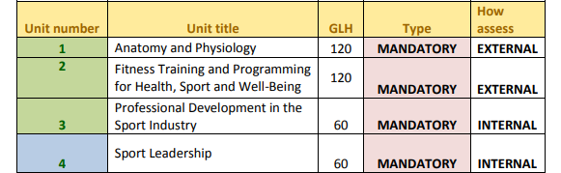

Points available for internal & external units
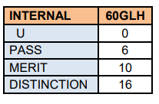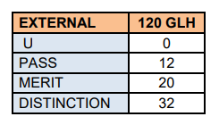

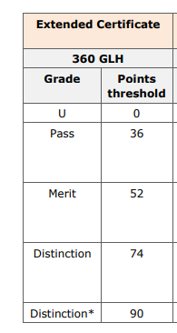

PEARSON EDEXCEL LEVEL 3 EXTENDED CERTIFICATE IN SPORT
At a Glance

Course Details

Course Title: BTEC National in Sport Level 3

Exam board: Edexcel/Pearson

Exam Board web site:
www.edexcel.com
www.btec.co.uk

Assessment method: The BTEC Sport Level 3 qualification is assessed both externally and internally via coursework based assignments.

Unit 1 - Anatomy and Physiology: is a written exam for 1.5 hours, worth 90 marks. This will be set and marked by Pearson.

Unit 2 - Fitness Training and Programming for Health, Sport and well-being: is the second externally assessed unit where pre-released information is released 1 week prior to a controlled assessment in exam conditions. 1 week prior to the assessment learners will receive information within controlled conditions where 4 hours can be spent preparing information. After this, on a date specified by Pearson, learners will then spend a further 2.5 hours applying this within controlled exam conditions.

Internal assessment (Unit 3 Professional Development in the Sports Industry & Unit 4 Sports Leadership):

Each student is allowed ONE submission for each assignment. Therefore, it is crucial that you get it right first time and meet the required assessment criteria. You should make sure that you fully understand the assignment or assessment task that you have been issued. Don’t be afraid to ask your unit teachers for help if you don’t understand what you need.

UNIT 1 - ANATOMY & PHYSIOLOGY
Task 1
Find a blank picture of the AXIAL skeleton and label it
Find a blank picture of the APPENDICULAR skeleton and label it

Task 2
Research and explain the functions if the skeleton and the types of movements it allows (make sure you reference your research)

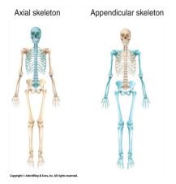

UNIT 2 – FITNESS TRAINING & PROGRAMMING FOR HEALTH, SPORT & WELL-BEING

Positive & Negative Lifestyle Factors
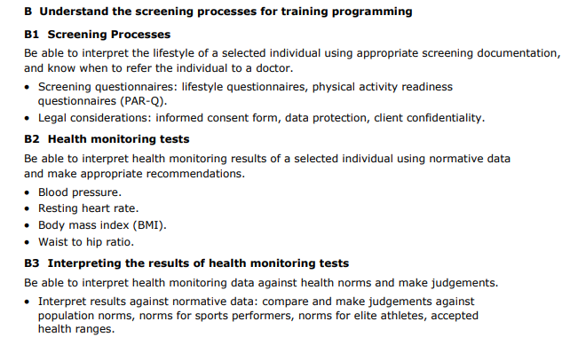

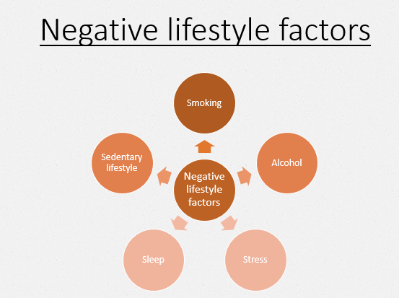
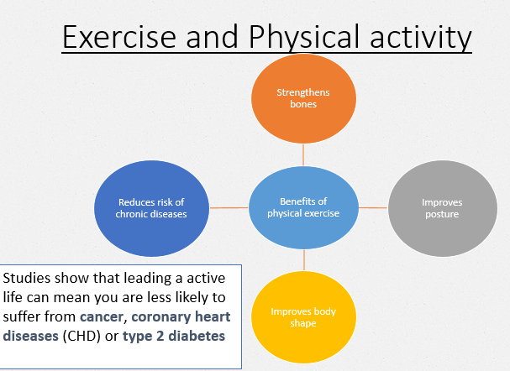

Task 1
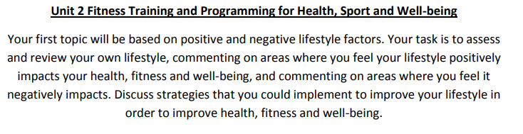
Use the information from the course specification to help you consider your own lifestyle.
Produce an A4 page which summaries the key information making links to all negative and positive lifestyle factors.

LISTEN, WATCH, READ, STUDY
Highlight the tasks as you complete them

Complete this MOOC.  Football: more than a game  University of Edinburgh  This course is open now! | Listen to this radio programme from the BBC World service. Sports Hour is a live Saturday morning sports show with reports, debate and humour. There are over 280 shows available covering all world sport.  BBC World Service: Sports hour  BBC Programmes | Read this article which explores the science behind wearing a helmet in sporting activities and how helmets are there to stop brain fracture and not concussion.  Football helmets don't protect against concussion - and we're not sure what does  Ideas TED | Watch this TED talk  which explores how racial stereotypes have infiltrated the language we use to discuss athletes.  Shouldn’t sports be colour-blind  TED Talks – Patrick Ferrucci | Complete this course.  Exercise prescription for the prevention and treatment of disease  Future Learn  Available now or 4th May 2020
Listen to this radio programme.  This is a daily podcast bringing you the latest from the Premier League, EFL, European football and more.  BBC Radio 5 Live  BBC Programmes | Read this article  which explores some of the key gender issues in sports.  Sports are designed around men – and that needs to change  Ideas TED | Watch this TED talk.  Are athletes really getting faster, better, stronger?  TED Talks – David Epstein | Listen to this podcast in which Calum and Buncey react to KSI's split-decision victory over Logan Paul in Los Angeles.  KSI vs Logan Paul II  BBC Sounds | Watch this TED talk.  My 12 pairs of legs  TED Talks – Aimee Mullins
Watch this TED talk in which Valorie Kondos Field, long-time coach of the UCLA women's gymnastics team, shares the secret to her success. Hint: it has nothing to do with "winning."  Why Winning doesn’t always equal success  TED Talk – Valorie Kondos | Watch this TED talk in which Christopher McDougall explores the mysteries of the human desire to run.  Are we born to run?  TED Talk – Christopher McDougall | Watch this TED talk. How much do you know about intellectual disabilities?  Special Olympics let me be myself – a champion  TED Talk – Matthews Williams | Watch this TED talk.  Amazing, inspiring feats of daring and determination that will bring you everywhere from the high skies to the deep sea. (Playlist of eight talks).  Extreme sports  TED Talks | Listen to this podcast from the British Journal of Sports Medicine. It covers all sorts of aspects of Sports Medicine, from the science behind running shoes to the power of sleep.  BJSM Podcast  Also available on other podcast providers – search ‘BJSM’

READING LIST
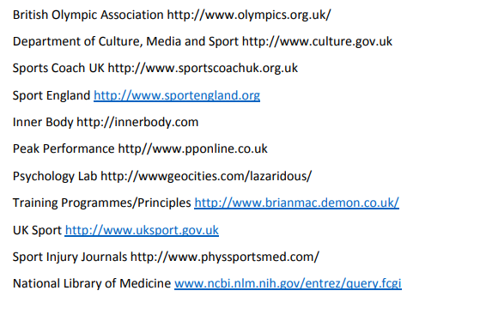

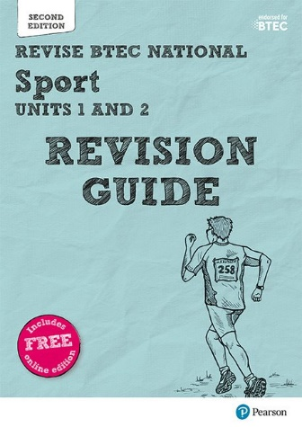
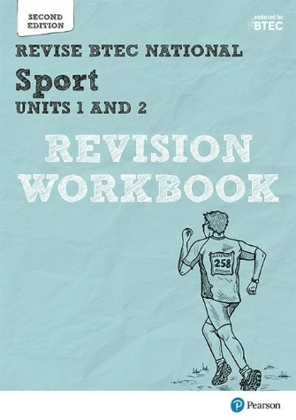
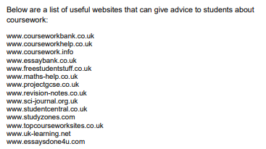

FACULTY EXPECTATIONS
There are some expectations that we set for all students who are studying BTEC Sport Level 3.
Students must bring their books, pens, pencils and a folder for their lessons.
It is expected that students attend all lessons promptly and in the correct uniform. If a student misses a lesson it is expected that they will speak to the member of staff who taught the lesson and catch up with the work.
Mobile phones are not to be used in lessons and must be switched off
Students will be provided with homework and coursework to be completed at home or in study time at school. It is expected that all students will hand their work in for marking promptly and to the best of their ability.
The workload is considerable and approximately six hours per week should be completed at home as independent research/study.
We hope you manage to stay safe and remain active over the lockdown period and the summer holidays. We look forward to welcoming you in September 2020.
Mr Kyle

