Pre year 12 BTEC Level 3 Engineering Research task
Any questions relating to these tasks please contact:
Miss Kirby – ekirby@stj.kent.sch.uk – (submit any work)
Mr Ambrose – mambrose@stj.kent.sch.uk
To become an Engineer, you must understand the materials and processes, which could be used to design and manufacture.
Research into a selection materials to gain a broad understanding and knowledge in preparation for your studies next year. This should be described, explained and analysed.
Selection two specific materials for each of the following categories:
Metal
Wood
Plastic
Smart/modern
This should be written as a report and include the following for each material which you research:
Properties/characteristic – good/bad quality, why would someone want to use the material?
Aesthetics – the look
Stock forms – what is a stock form, which ones are suitable for each material?
Cost – at when a stock form
What engineering product could they be used in manufacturing?
Include anything else you feel is important about the individual material.
Then…
Research, analysed and evaluate in to 6 manufacturing processes which are suitable for each one of the 6 materials you have researched in your report. It is important to have knowledge on processes as well as materials, so you can achieve the most efficient and cost affective outcome when manufacturing. Look at processes which are used in industry not in the school workshop.
You should try to include the following:
Step by step guide
Wastage of material
Cost of the process
Accuracy
Training – skilled/non-skilled labour
Other materials which are compatible with this process

Put all websites and sources at the bottom of the report.
Pre year 12 BTEC Level 3 Engineering written task
You will have to take two exams to complete this course. Unit 3 is about re-design and development of an engineered product. The information you have gathered from the research task will potentially support you in this section, depending on which materials and processes you selected. You may need to research additional ones for this section.
Complete the written unit 3 exam questions below, you will have to complete some drawings within this. The real exam is 8 to 10 hours, so take your time with your answers.
Below is the client brief and the specific points of what can and can not be changed to re-design the product.
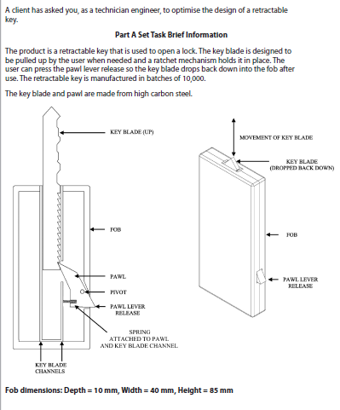

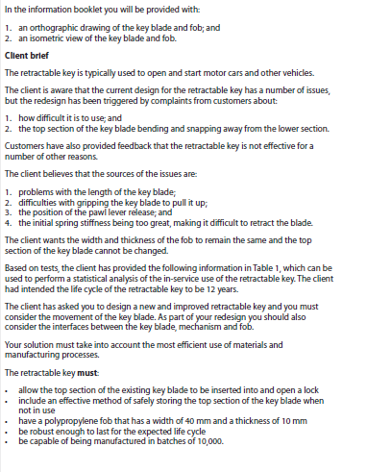

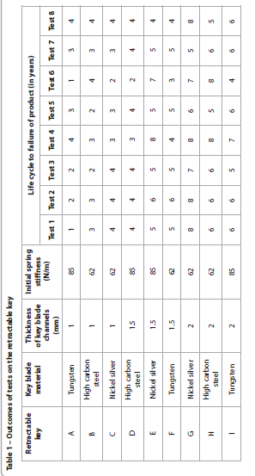

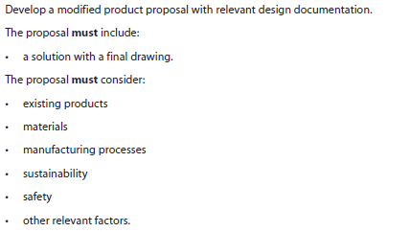
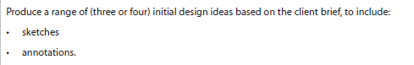
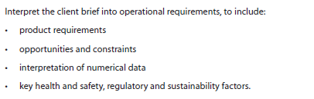
Now you have seen the engineered product, (key fob) brief and data. Complete the questions below. You may need to do some additional research on materials, processes, constraints, safety, existing products, etc, to support you in completing the questions fully.

Weblink to BTEC Level 3 Engineering specification - https://qualifications.pearson.com/en/qualifications/btec-nationals/engineering-2016.html

