OCR Philosophy of Religion

AS Level

Exam Board: OCR

Content overview - Specification at a glance
In OCR’s A level Philosophy and Ethics (Religious Studies), you will study three components that are externally assessed: each unit is 33% of the marks, these are
• Philosophy of religion (01)
• Religion and ethics (02)
• Developments in religious thought Christianity (03)
Please, use this link to access the course specification
https://ocr.org.uk/Images/242913-specification-accredited-a-level-gce-religious-studies-h573.pdf

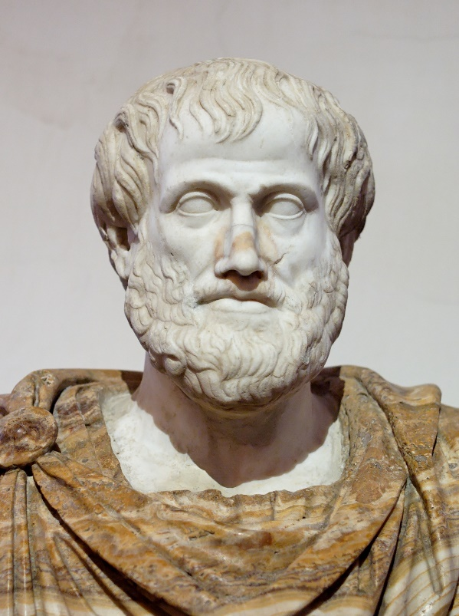
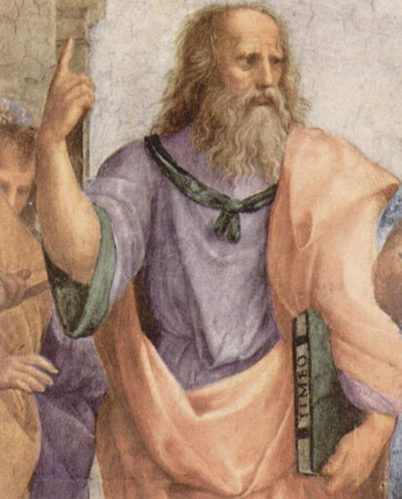

Name: _________________________________________
Group: ________________________________________
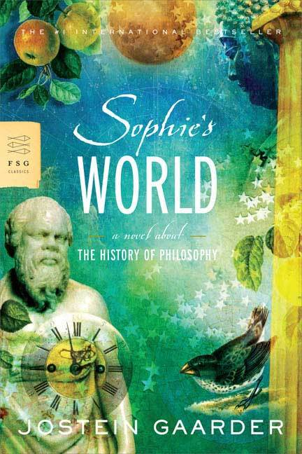
WHAT IS PHILOSOPHY?
Dear Sophie,
Lots of people have hobbies. Some people collect old coins or foreign stamps, some do needlework, others spend most of their spare time on a particular sport.
A lot of people enjoy reading. But reading tastes differ widely. Some people only read newspapers or comics, some like reading novels, while others prefer books on astronomy, wildlife, or technological discoveries.
If I happen to be interested in horses or precious stones, I cannot expect everyone else to share my enthusiasm. If I watch all the sports programs on TV with great pleasure, I must put up with the fact that other people find sports boring.
Is there nothing that interests us all? Is there nothing that concerns everyone--no matter who they are or where they live in the world? Yes, dear Sophie, there are questions that certainly should interest everyone. They are precisely the questions this course is about.
What is the most important thing in life? If we ask someone living on the edge of starvation, the answer is food. If we ask someone dying of cold, the answer is warmth. If we put the same question to someone who feels lonely and isolated, the answer will probably be the company of other people.
But when these basic needs have been satisfied--will there still be something that everybody needs? Philosophers think so. They believe that man cannot live by bread alone. Of course everyone needs food. And everyone needs love and care. But there is something else--apart from that--which everyone needs, and that is to figure out who we are and why we are here.
Being interested in why we are here is not a "casual" interest like collecting stamps. People who ask such questions are taking part in a debate that has gone on as long as man has lived on this planet. How the universe, the earth, and life came into being is a bigger and more important question than who won the most gold medals in the last Olympics.
The best way of approaching philosophy is to ask a few philosophical questions:
How was the world created? Is there any will or meaning behind what happens? Is there a life after death? How can we answer these questions? And most important, how ought we to live? People have been asking these questions throughout the ages. We know of no culture which has not concerned itself with what man is and where the world came from.
Basically there are not many philosophical questions to ask. We have already asked some of the most important ones. But history presents us with many different answers to each question. So, it is easier to ask philosophical questions than to answer them.
Today as well each individual has to discover his own answer to these same questions. You cannot find out whether there is a God or whether there is life after death by looking in an encyclopaedia. Nor does the encyclopaedia tell us how we ought to live. However, reading what other people have believed can help us formulate our own view of life.
Philosophers' search for the truth resembles a detective story. Some think Andersen was the murderer, others think it was Nielsen or Jensen. The police are sometimes able to solve a real crime. But it is equally possible that they never get to the bottom of it, although there is a solution somewhere. So even if it is difficult to answer a question, there may be one--and only one--right answer. Either there is a kind of existence after death--or there is not.
A lot of age-old enigmas have now been explained by science. What the dark side of the moon looks like was once shrouded in mystery. It was not the kind of thing that could be solved by discussion, it was left to the imagination of the individual. But today we know exactly what the dark side of the moon looks like, and no one can "believe" any longer in the Man in the Moon, or that the moon is made of green cheese.
A Greek philosopher who lived more than two thousand years ago believed that philosophy had its origin in man's sense of wonder. Man thought it was so astonishing to be alive that philosophical questions arose of their own accord.
It is like watching a magic trick. We cannot understand how it is done. So we ask: how can the magician change a couple of white silk scarves into a live rabbit?
A lot of people experience the world with the same incredulity as when a magician suddenly pulls a rabbit out of a hat which has just been shown to them empty.
In the case of the rabbit, we know the magician has tricked us. What we would like to know is just how he did it. But when it comes to the world it's somewhat different. We know that the world is not all sleight of hand and deception because here we are in it, we are part of it. Actually, we are the white rabbit being pulled out of the hat. The only difference between us and the white rabbit is that the rabbit does not realize it is taking part in a magic trick, unlike us. We feel we are part of something mysterious and we would like to know how it all works.
P.S. As far as the white rabbit is concerned, it might be better to compare it with the whole universe. We who live here are microscopic insects existing deep down in the rabbit's fur. But philosophers are always trying to climb up the fine hairs of the fur in order to stare right into the magician's eyes.
Are you still there, Sophie? To be continued . . .

What is philosophy?
Answer this question based on your reading of the excerpt above.
What is philosophy? _________________________________________________________________________
_________________________________________________________________________
_________________________________________________________________________
_________________________________________________________________________
_________________________________________________________________________
_________________________________________________________________________
_________________________________________________________________________
_________________________________________________________________________
_________________________________________________________________________
_________________________________________________________________________
_________________________________________________________________________
_________________________________________________________________________
_________________________________________________________________________
_________________________________________________________________________
_________________________________________________________________________
Why is philosophy important? _________________________________________________________________________
_________________________________________________________________________
_________________________________________________________________________
_________________________________________________________________________
_________________________________________________________________________
_________________________________________________________________________
_________________________________________________________________________
_________________________________________________________________________
_________________________________________________________________________
_________________________________________________________________________
_________________________________________________________________________

Ancient Greek Influences on Philosophy of Religion

Plato: An Introduction

Plato was an Ancient Greek philosopher who lived from 427 – 347 BCE, and a former student of the great philosopher Socrates. Plato is perhaps one of the most influential and well-known philosophers in history. His work influenced the development of philosophy throughout the Western world. His early works are about Socrates' philosophy and most of Plato's books feature Socrates as the leading character.
In his later works, Plato wrote about many issues; including the existence of the soul, the nature of beauty and theories of governance. Plato founded his own school of philosophy called the Academia (from which we get the word 'academy' in English).

Theory of Forms

In your head, imagine a cat. It might be white, black, ginger, tabby...the list goes on. Was your idea of a cat exactly the same as your neighbour? Probably not, but there are a set of characteristics that you will both have imagined: a tail, whiskers, four legs, paws. These characteristics resemble the idea of what a cat is. You would both be able to recognise a cat if one walked past you, even if it didn't look exactly the same as the cat you imagined.
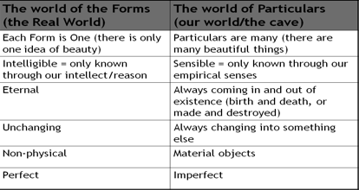
Plato saw a very important distinction here: the world of appearances and the real world. He proposed that the world we live in is a world of appearances, but the real world is the world of Forms. Forms are the idea of what a thing is, like the idea of a cat. All cats that exist in our world, the material world, conform to the idea, or the Form, of a cat. A Form does not change, it is a concept that is everlasting. Plato argued that the true Form of everything (including cats!) must exist somewhere, in a different reality; he called this the world of Forms.
As a great philosopher, Plato wasn't all that interested in discussing the Form of a cat. He focused more on concepts like beauty, truth and justice. He saw that concepts like beauty can be applied to all sorts of different things. Both a person and a piece of music can be beautiful, and so reveal some characteristic of beauty. But neither clearly define beauty, because they are different, and other different things can be beautiful too (like a painting or a landscape). This led Plato to suggest that there was a Form of beauty, to which all these things correspond to some extent.
In our world, there are only the shadows and images of the Forms. Material things in our world imitate a form. As our understanding is limited to the objects that exist in our material word, the Forms go beyond human comprehension. So how do we recognise the Form of beauty in a beautiful person?

Plato argued that the reason we recognise the Forms is because when we are born we have a dim recollection of them. He said that there is an inner part of us, that most people call the soul, which is immortal and unchanging. Before the soul became tied down to the body, it was connected to the real world of Forms. The reason that we can all recognise beautiful things or kind acts is because we have all seen the Forms before. Plato’s evidence for this claim was the fact that a person can instinctively know that something is beautiful, even if we haven’t been taught it.
Therefore, Plato concluded, it must be true that we have an immortal soul which was once part of the world of the Forms.
Thought Point
The Philosopher: Plato said that the philosopher is someone who tries to escape the world of appearances and with their mind see the Forms that lie behind appearances. As a true philosopher has knowledge of the Forms, he argued that they are the most suitable people to rule society.
Do you agree?

The Form of the Good
Plato believed that some things do not conform to a Form, like number and evil. He also thought that some Forms were greater than others; universal qualities like justice, truth and beauty. These ideal Forms all have something in common – they all have the presence of Good in them. Therefore, Plato said that Good is the most important Form. It is ‘the Form of the Forms’ (or ideal of the ideal Forms).
Plato argued that once you can understand Good, then you can understand all other Forms because they are all aspects of goodness. The Good is like the Sun: it illuminates everything else, and the further away you get, the paler things become. In his analogy of the Sun, Plato says that the Form of the Good makes things knowable, and that it is the source of the other Forms. Therefore, knowledge of the Good is the highest knowledge a human is capable of. An ordinary person struggles to see past the illusion of this material world because they are ruled by their senses. Only the person who questions and investigates can learn the truth behind the illusion. Who is that person? The philosopher, of course!
Activity
1. Write a definition of the Forms.
2. Explain why Plato says the world we live in is not the real world.
3. How do you explain the fact that everyone is able to identify something like kindness?
4. What would you say to challenge the idea that the recognition of Form proves we have an eternal soul?
Plato’s Analogy to Sight:
Sight requires both light and the eye to see clearly. Light symbolises the Form of the Good. Plato’s implication is that without the knowledge of the Form of Good one does not see clearly; the same as trying to see in complete darkness.

What are the strengths and weaknesses?
Strengths | Weaknesses
The theory of Forms explains why we can all recognise the same essential elements in something. The fact that we can all recognise beauty, without being taught about it, must mean we have some collective experience of beauty. Plato’s thoughts on the eternal unchanging soul and the world of Forms explains this. | Nobody can prove Plato’s world of Forms exists. It is an alternate reality, another universe, it is not within human knowledge or experience. Therefore, there is no real empirical evidence for its existence.
Plato’s theory helps us to understand why there are imperfections in the world. It doesn’t rely on us accepting the presence of an all-present higher being who creates imperfections for reasons we can’t understand. Imperfections are merely a result of the fact we live in the material world, and material objects are merely shadows of Forms. | If you have a Form of a Form, or an ideal Form of Forms (like the Form of the Good), then what’s stopping you from having an ideal Form of that ideal Form? And an ideal Form of the ideal Form of that ideal Form? This argument is called infinite regression – it goes on forever backwards.
It encourages us to question things in order to learn, rather than accepting things at face value. | What about opinion? Some people argue there is no such absolute value as ‘Good’ as it is subjective; people have their own opinion as to what is good. Therefore, it is unlikely that two people will always come to the same conclusion about what is good.
 | It is unlikely that everything in existence has an ideal form. Is there an ideal slug or type of cancer?
 | Plato is not clear how the world of Forms relates directly to our world. Do the Forms have to relate to a specific variety of material object? For example, does the Form of a cat have to relate to a specific breed of cat? Is there a particular Form for each breed?
 | Plato says that the senses are inferior, and that we should not rely on them. Yet people have been relying on their senses for survival for thousands of years.
 | It is not very logical at first instance to say there is a world we cannot see. Therefore, the theory may not be an obvious conclusion of logical reasoning.
What do you think about Plato’s theory of Forms?
_________________________________________________________________________
_________________________________________________________________________
_________________________________________________________________________
_________________________________________________________________________
_________________________________________________________________________
_________________________________________________________________________
_________________________________________________________________________
_________________________________________________________________________
_________________________________________________________________________
_________________________________________________________________________
_________________________________________________________________________
_________________________________________________________________________
_________________________________________________________________________

Analogy of the Cave
The Analogy of the Cave is one of the most famous passages from Plato’s Republic. Plato uses this analogy, and two others, to illustrate his theory of Forms. The Cave is often said to be allegorical, which means that different elements of the story are symbolic of the situation in which people find themselves.
Imagine people sitting on chairs in a cave. They are all facing the wall of the cave. They are chained to chairs. The only light in the cave comes from a fire. There is a wall behind the prisoners and there is a fire located behind the wall. Behind this wall, other people are walking up and down and carrying statues on their heads. What the prisoners chained to the chairs see is the shadows cast by the statues on the wall in front of them.
The prisoners believe that the shadows are reality because that is all they see. If they hear people behind the wall speaking they assume that these voices come from the shadows.
Imagine if one of the prisoners is freed. At first when he is turned around, he is confused. He doesn’t understand what he sees. Slowly, his eyes become accustomed to the firelight and he can see the statues. He is confused still – he believes the shadows are reality.
Then, the released prisoner is dragged up a long ramp at the back of the cave, and emerges into sunlight. The sunlight is blinding, and so he tries to flee back into the cave. Imagine that someone prevents him from fleeing, and slowly his eyes adjust. He is able to see the world around him. Finally, he looks up and realises the importance of the sun. He sees that it supports life and the seasons. Now, he doesn’t want to go back underground.
However, he might remember his friends in the cave, and want to go back and teach them about reality. When he gets back in the cave, his eyes cannot adjust to the darkness and he cannot see clearly. When he tells the other prisoners his story, and they see he cannot see in the darkness, they decide it is better not to go above ground and wish to put to death anyone who tries to free another prisoner.
Plato’s analogy of the Cave demonstrates the importance of questioning everything in order to distinguish between the material world and the real world. In the analogy, the prisoner who is freed is representative of a philosopher. He breaks away and makes the journey out of the cave to find out what is really going on. In the outside world he discovers the sun and realises it gives life to everything.
Using the table below, identify what the other features of the analogy represent.

Thought Point
In Republic, Plato states that the statues carried along the wall are made of wood and stone. Why do you think this is important?

The Cave
The Shadows
The Prisoners
The Sun
The Outside World
Those Carrying the Statues **

** Stretch and Challenge
In the analogy of the Cave, the prisoner returns to those still inside the cave. This journey is representative of a philosopher educating others about the real world. Once they have learned the truth, they have a duty to return to the Cave and challenge the ideas of reality. However, upon his return the other prisoners want to kill him. This can be seen as representing society’s unwillingness to question what they are told, something that Socrates did. Plato undoubtedly had in mind the fate of Socrates, who challenges the ideas of his day and was condemned to death.

But what is real? Everyone in the analogy is convinced that what they are looking at is real. The prisoners’ knowledge is based entirely on their sense of sight and sound, and they accept this as reality. Plato is showing us that empirical knowledge (gained from the senses) cannot be accepted as fact; it does not show reality. Contrast this to the idea of the freed prisoner. After emerging into the real world, he uses his power of reasoning to reach a philosophical understanding of the truth. This knowledge of reality based entirely on reasoning is called a priori – gained wholly from logical reasoning and independent of sensory experience.
Plato’s argument is absolutist; it is fixed. He believed his argument to be true for all people in all places at all times. It is universal.
Arguments in Support of Plato:
- Plato makes a good point that empirical knowledge can be flawed (as was shown by the prisoners thinking the shadows to be real), this is because we live in an imperfect world of appearances and imitation of the Forms. The better type of knowledge is logical reasoning (a priori) as it is based on philosophical reason not our suspect senses.
- Plato gives a reason for the imperfections of the world which we see all around us, he admits that the world is imperfect copies of the real world of the Forms.
- We recognise these imperfect copies of the Forms as we lived there before.
Criticisms of Plato’s Argument:
- There is an unclear link between the World of Appearances and the Forms. The cave analogy doesn’t tell us how they are connected, e.g. movement from imitations -> Forms...is there anything in the middle??
- How does one actually realise the truth and the reality of the Forms in order to become enlightened? Plato mentions that the hard journey out of the cave is analogous to the soul leaving this world. That may mean a person must die in order to realise the Forms. So how can a person come back and tell the people inside the cave if he is dead? Or does it mean we can realise the truth while being here, but how does one do that?
- But Plato’s argument is Absolutist (i.e. it is fixed and universal truth for all in all time). But not everyone may accept this, certainly Aristotle didn’t. Aristotle was critical of Plato’s argument because he could not agree that the form of something has a separate existence over and above the particular.
- No concrete proof that world in cave or outside is real. How can you prove the prisoners and philosopher is right or wrong?
- Just because someone is philosophically enlightened and intelligent, does that necessarily make them perfect for leadership? For example, there is a common stereotype that really clever people have low common-sense and empathy for less-intelligent people, but a leader needs to know his/her people to be a good leader.
Review
1. Explain the link between Plato’s forms and the Cave analogy.
2. ‘If the cave dwellers are happy in their ignorance, it is better to leave them to it’. Do you agree?
3. Make a list of the pros and cons of having philosophers as the leaders of society.

 | Religious Studies - Philosophy, Ethics and Theology
 | Video clip resources with URL links to help you find out more about this great course and aid independent learning May 2020
5 | - Lifeboat Ethics https://www.youtube.com/watch?v=bcKg7a3lNzw&app=desktop  - BBC A History of Ideas  - Crash Course Philosophy, Youtube playlist covering different topics Crash Course Philosophy  - A student who has a series of clips on GCSE and on the A level OCR course Ben Wardle -  - A huge variety of resources on Ethics, Philosophy and other religions for 16 plus form REOnline 16+ Christianity  - School of Life, Youtube Playlist covering key western philosophers WESTERN PHILOSOPHY  - Documentary 2 weeks more on iplayer. Free Will: Who Is Really in Charge of Our Minds?  - Watch the debate live. High profile and interesting scholars: The Big Conversation | Atheist and Christian debates  - BBC In our Time Philosophy - https://www.bbc.co.uk/programmes/p01f0vzr  - Ted Talks - Just browse and watch those which grab your interest! You can search by topic. This link takes you to philosophy related talks. https://www.ted.com/talks?sort=relevance&q=philosophy  - Philosophy Talk | The program that questions everything...except your intelligence.  - Wireless Philosophy Learn about Philosophy with professors from Yale, Stanford, Oxford, MIT, and more. https://www.youtube.com/user/WirelessPhilosophy/featured  - Gregory B. Sadler  - Ethics Online: Home  Films/series that might be of use (note some of these are 18 Cert)  - Carnage (Vegan film) https://www.bbc.co.uk/iplayer/episode/p04sh6zg/simon-amstell-carnage  Some Philosophical Films  - Erin Brockovich  - The Matrix  - Bruce Almighty  - The Truman Show
Should you wish to discuss or find out more about this course, please get in contact with Religious Studies (Philosophy, Ethics and Theology) course teachers:
Mr P O'Connell
POConnell675@stj.kent.sch.uk
Mr F Juma
FJuma518@stj.kent.sch.uk

