An introduction to the Level 3 Subsidiary Diploma in Music
Everything you need to know about the course

A quick summary of the course:

- The Level 3 Subsidiary Diploma in Music is a two-year course
- There are six units. Three units will be completed in year 12 and three in year 13
- The course is designed to give you the opportunity to develop you skills as a musician and a performer and in a range or environments

Year 12

Unit 23 – Music Performance Techniques

In this unit, you will develop your skills as a solo musician and as part of an ensemble. Throughout the unit you will keep a rehearsal log setting goals and celebrating your achievements.

Unit 24 – Music Project

This unit allows you to plan and perform in a concert at the end of the year. You will have individual responsibilities such as designing posters, contacting venues, and organising rehearsals. You will also have group meetings to make sure the concert is a success. All your evidence will be kept in a sketch book that you submit at the end of the unit. This is very similar to Unit 2 that you may have done in years 10 and 11.

Unit 22 – Music Performance Session Styles

In this unit, you will develop your skills as a musician in a range of different genres, such as pop, rock, soul, R&B, folk, etc. You will be assessed on your ability to play your instrument or sing in a range of different circumstances. These include a live concert, a jamming session, and a recording session

All three units lead to the final concert at Woodville Halls in March of year 12 which you will organise as a class.

Year 13

Unit 30 – Pop Music in Practice

This unit will allow you to study the development of Pop Music from 1950 to the present day and be able to demonstrate your knowledge of different genres as well as how pop music has developed. You will also perform as a soloist and as part of an ensemble. This unit also gives you the opportunity to write and record your own songs

Unit 33 – Solo Music Performance Skills

This unit gives you the opportunity to record an extended programme of music on your chosen instrument or voice. As well as using your rehearsal diary to document your progress, you will also perform an extended programme of music of about 20 mins at the end of the year.

Unit 40 – Working and Developing as a Musical Ensemble

In this unit you look at what it takes to be part of a successful ensemble. Everything from choosing the right repertoire to improving stage presence and communication with the audience. You will regularly maintain your rehearsal log, talking about what you did in rehearsals and how you would like to develop as a musician.

Overall this is a fantastic course for any musicians looking to develop as a performer and a song writer and gain a better understanding of the music industry and what it takes to be a successful musician in the 21st century.

Unit 22 – Music Performance Session Styles

BTEC Level 3 Subsidiary Diploma in Music

This unit allows students to develop their skills as a performer in different styles of music. In order to increase your opportunities for employment as a performer, you must develop your ability to reproduce the authentic sounds and performance characteristics of historically and culturally important genres and artists.

Task 1

Elements of musical genres

Analyse music from at four contrasting genres of music, identifying musical elements and interpretive devices that define each style. You can choose any four genres, such as jazz, rock, soul, funk, blues, classical, etc. You must then create a written article about four different genres using examples from relevant artists within each genre.

For each genre you need to include the following:

- An explanation of the genre referring to the elements at the bottom of the page.
- A description of two songs from each genre you have chosen, including an explanation of how the song fits in with that genre (including a YouTube link).
- A comparison of the songs you have chosen and how they are similar / different.
- An explanation of the importance and contribution the songs make towards the genres from which they are taken

Your assignment must be a minimum of 1500 words

Please email your completed assignment to sfarrelly@stj.kent.sch.uk

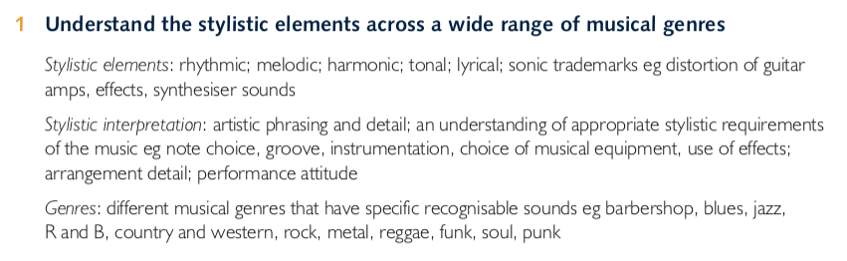

This is a useful website you can use to complete the assignment. Remember to put information in your own words.

https://www.openmicuk.co.uk/advice/types-genres-of-music/

