Progression to Post-16 Study in Information Technology

Course Outline
The Information Technology course has four units. They are:
- Information Technology Systems – an externally assessed unit where you will learn about the theory relating to information technology use, such as hardware, software, networks, as well as considering the ethical and legal issues surrounding IT use

- Cyber Security and Incident Management – an externally assessed unit surrounding cyber security threats and vulnerabilities and the methods used to protect organisations against threats and managing security incidents.

- Relational Database Development – In this unit you will examine relational database development principles to understand the importance of data storage and normalisation techniques and apply your skills to design and develop data storage solutions to meet a client’s requirements.

- Website Design– in this unit you will learn the principles of website design and apply them to devising your own website to a set brief. For the internal assessment you will need to plan, create, test and evaluate a website for a specific purpose

Throughout the course you will need to use and improve upon a range of IT skills, including
- Internet research – being discerning and selective

- Word processing – the coursework will need to be presented, often as a business report

- Presentation using PowerPoint – some coursework tasks, require a presentation

- Email – using this in a professional manner to liaise with staff and clients

- Spreadsheets – to analyse and present numerical data, for example a bar chart

- Referencing sources – this must be done using the Harvard referencing system. Information on how to do this can be found here https://www.ukessays.com/referencing/harvard/

Recommended Resources
https://www.bbc.co.uk/bitesize/levels/z98jmp3 - Whilst aimed at GCSE, this will also provide useful information on many areas, especially if you did not do GCSE Computing. You can use the information in the ICT, Computing and Digital Technology areas
https://www.bbc.co.uk/news/technology - this area of the BBC news website will provide you with up-to-date information on technology development
www.teach-ict.com – a website totally devoted to IT and Computing.
https://www.thinkuknow.co.uk/ - website for e-safety advice
Pearson Textbook – Electronic copy provided by school once you start the course.
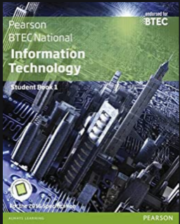
PG Online textbook – excellent for Unit 1 theory – available from Amazon
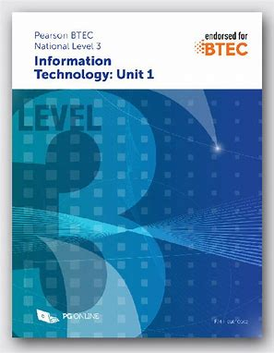
Pearson Revision Guide – invaluable for the externally assessed units – Available on Amazon
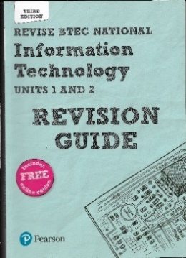
Preparatory Activities
Task | Date | Activities
1 |  | Digital divide  The digital divide is one ethical, social and moral issue surrounding the use of IT.  Complete the following using the recommended resources:  - Define the term digital divide  - Explain causes of the digital divide  - Find evidence to prove that the digital divide exists, i.e. the % of people with internet connection across countries  - What are the impacts of the digital divide for individuals, businesses and society as a whole?  - What can businesses or other organisations do in order to minimise the digital divide and its consequences?  You can present this as either a PowerPoint presentation or a word document. Include a bibliography of the sources that you have used.
2 |  | Cyber Security  Create a short PowerPoint surrounding the following areas:  - Types of Malware and definitions, provide any article examples you can find online of them in effect  - Describe different social engineering real-world situations and the impacts they can have.  - Outline how permissions and policies help protect networks from cyber threats.  - What legislation do businesses have to abide by in regards to Cyber Security?  - What legislation restricts people’s involvement in cybercrimes?  - Describe encryption and identify different types of encryption and how they differ.
3 |  | Connectivity  Read this article from the BBC: https://www.bbc.co.uk/news/technology-52414280  - What is an ethernet cable?  - What is bandwidth?  - Why does more people using the internet affect the speed?  - Why would gaming need a faster speed than general browsing?  Present your answers as a word-processed file
4 |  | Computer Systems  This task is all about understanding what is meant by a computer system.  - Make a collage or mind map of examples of computer systems  - Explain what is meant by the input-process-output cycle  - Explain the use, advantages and disadvantages of at least FOUR input devices  - Explain the use, advantages and disadvantages of at least FOUR output devices  - Explain the use, advantages and disadvantages of at least FOUR storage devices  - Cloud storage is a method where storage is not on a physical device, but on a remote server. Analyse the pros and cons of using cloud storage on (a) an individual and (b) on organisations  - A bibliography  Present the work as a word-processed report
5 |  | Emerging technology  Emerging technology is new technology. Select FOUR from the following:  - Artificial intelligence  - Biometrics  - Robotics  - Virtual reality  - Drones  - Augmented reality  - 3D printing  - Internet of things  For each one you select do the following  - Explain what this technology is  - Explain how it could be used by individuals at home  - Explain how it could be used within the workplace  - Implications of these emerging technologies -both positive and negative  Present the tasks as a word-processed document

