Progression to Post‑16 Study
OCR A Level Computer Science

Course Outline
OCR A Level Computer Science (H446) is assessed through two written exam papers and one programming project (a non‑exam assessment, or ‘NEA’). There are three components:
- Computer Systems (Component 01) – a 2-hour 30-minute written paper worth 40% of the A Level (140 marks). This component covers the theory: processors, input/output and storage, software and software development, exchanging data, networks and databases, data types and data structures, Boolean algebra, and legal, moral, cultural and ethical issues.
- Algorithms and Programming (Component 02) – a 2-hour 30-minute written paper worth 40% of the A Level (140 marks). This component focuses on problem solving elements of computational thinking, programming techniques, computational methods, and how to design and apply standard algorithms (such as searching and sorting).
- Programming Project (Component 03) – the non-exam assessment, worth 20% of the A Level (70 marks). You will choose a real problem, then analyse it, design a solution, develop the solution in a suitable programming language accepted by OCR, and evaluate it – producing a written report alongside your working program.

Skills you will use and develop
Throughout the course you will need to use and improve upon a range of skills, including:
- Programming – writing, testing and debugging code (most students use Python; OCR also accepts languages such as C#, Java, VB.NET and others).
- Computational thinking – breaking problems down, spotting patterns and designing step‑by‑step solutions.
- Mathematical skills – binary and hexadecimal, Boolean logic, and comparing the efficiency of algorithms.
- Technical writing – explaining ideas clearly and precisely and writing up your programming project.
- Independent research – being selective and discerning with sources and keeping up with developments in technology.

Recommended Resources
These are the resources we use and recommend. You do not need to buy everything – the free resources below are an excellent starting point over the summer.

Resources we use in lessons
- Craig ‘n’ Dave – our main video resource. Every learning objective in the specification has a short video. The student video index is free to use: student.craigndave.org
- SmartRevise – our online platform for spaced‑repetition quizzing and exam practice. You will be given a login at the start of the course: smartrevise.craigndave.org

Free websites
- https://www.physicsandmathstutor.com/computer-science-revision/a-level-ocr/ - In-depth break-down of every element of the A-level CS specification, also includes lots of question papers and mark schemes for individual topics as well.
- https://revisionworld.com/level-revision/computer-science-level-revision - Topical revision resource with a focus on achieving higher grade boundaries.
- https://code.smashyourexams.com/ - Interactive online platform that enables students to actively practice their python coding using different scenarios, provides help and tutorials to assist students with their thought processes and approaches to complex technical situations.
- https://compsciwizard.com/ - - Valuable resource with daily 10minute long practices, good for consistent revision practice.

Recommended books
OCR AS and A Level Computer Science (PG Online) – by P.M. Heathcote & R.S.U. Heathcote. A clear, well￼laid￼out, OCR￼endorsed textbook covering all the theory. Available from Amazon and PG Online.
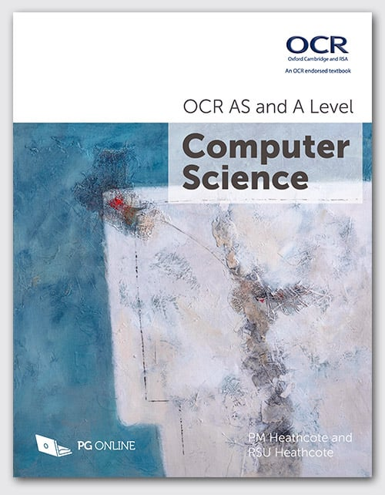

OCR A Level Computer Science (Hodder Education) – by George Rouse, Jason Pitt & Sean O’Byrne. An OCR￼endorsed textbook that also covers the programming project.
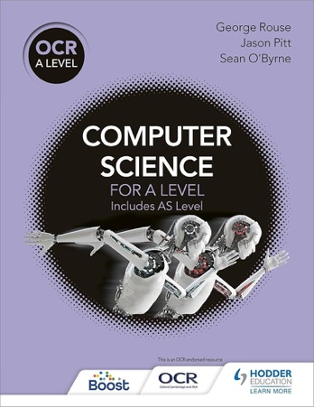

ClearRevise Exam Tutor OCR A Level Computer Science H446 (PG Online) – worked exam questions with model answers and examiner tips, plus full practice papers for Paper 1 and Paper 2 – useful later in the course for exam preparation.
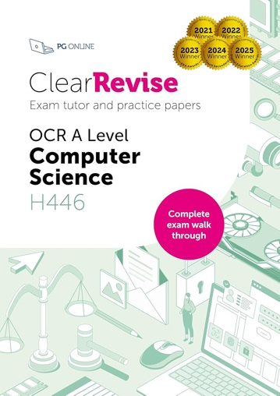

You will be told which textbook to use at the start of the course – please do not buy one until then.

Preparatory Activities
Complete as many of the following tasks as you can over the summer. They are designed to introduce key ideas from the course and to build the core skills you will rely on. Bring your completed work to your first lesson. Record the date you complete each task in the table.
Task | Date completed | Activities
1 |  | Data representation – number systems  Computers represent all data as binary. This task builds the number‑system fluency you will use throughout the course. Using the Craig ‘n’ Dave videos and BBC Bitesize, complete the following:  - Explain why computers use the binary (base‑2) system rather than denary (base‑10).  - Convert these denary numbers to 8‑bit binary: 25, 142, 200. Show your working.  - Convert these binary numbers to denary: 01011010, 11110000.  - Explain what hexadecimal is and why it is used in computing. Convert 2F and B7 (hex) into both binary and denary.  - Add the binary numbers 10110011 + 01010110. Explain what an ‘overflow’ error is and why one occurs here.  Present your answers as a word‑processed document with your working clearly shown.
2 |  | Inside the CPU – the Fetch–Decode–Execute cycle  Component 01 begins with the structure and function of the processor. Research the following and produce a short illustrated guide (poster, document or PowerPoint):  - Draw and label the main components of the CPU: ALU, Control Unit and the registers (PC, ACC, MAR, MDR, CIR).  - Explain the purpose of the data bus, address bus and control bus.  - Describe each stage of the Fetch–Decode–Execute cycle and what happens to the registers at each step.  - Explain how clock speed, number of cores and cache size each affect CPU performance.  - Briefly explain the difference between Von Neumann and Harvard architecture.  Include a bibliography of the sources you used.
3 |  | Algorithmic thinking – flowcharts and pseudocode  Computational thinking is at the heart of Component 02. Algorithms can be expressed as flowcharts or pseudocode. Complete the following:  - Explain, in your own words, what an algorithm is and the difference between a flowchart and pseudocode.  - Draw a flowchart for an algorithm that asks the user for a number and outputs whether it is odd or even.  - Write pseudocode for an algorithm that finds the largest number in a list of ten numbers.  - Write pseudocode for an algorithm that calculates the average of the numbers a user enters until they type ‘stop’.  Familiarise yourself with the OCR pseudocode conventions – these are in Appendix 5d of the specification (the ‘Languages and Boolean logic guide’) and are used in your exams.  Present your work as a word‑processed document.
4 |  | Get coding in Python  Programming is a practical skill that improves with regular practice. OCR accepts a range of languages but most students use Python. Using a free platform from the Recommended Resources, work through introductory tutorials and then write short programs that:  - Ask the user for their name and age, then print a personalised message.  - Use a FOR loop to print the times table for a number the user chooses.  - Use a WHILE loop and an IF statement to make a simple ‘guess the number’ game.  - Use a function that takes two numbers and returns the larger of the two.  Keep a copy of each program (the code and a screenshot of it running) in one document.  Submit your programs as a single word‑processed document, or share your code files.
5 |  | Networks and the internet  Component 01 covers how data is exchanged across networks. Research and answer the following:  - Explain the difference between a LAN and a WAN.  - What is a network protocol? Describe the purpose of TCP/IP, HTTP and HTTPS.  - Explain the difference between client–server and peer‑to‑peer networks, giving an example of each.  - What is the difference between the internet and the World Wide Web?  - Explain what an IP address and a MAC address are, and how they differ.  Present your answers as a word‑processed report with a bibliography.
6 |  | Legal, moral and ethical issues in computing  Component 01 requires you to evaluate the impact of technology on society. Choose TWO of the issues below and, for each, write a short report:  - Artificial intelligence and automation in the workplace  - Data privacy and the way companies use personal data  - The environmental impact of computing and e‑waste  - Computer misuse, hacking and cyber‑crime  For each chosen issue: explain what it is, describe a real‑world example you have researched, and discuss the positive and negative impacts on individuals, organisations and society. Identify any relevant UK legislation (for example the Data Protection Act / GDPR, the Computer Misuse Act 1990, or the Copyright, Designs and Patents Act 1988).  Present your work as a word‑processed document with a bibliography.
7 |  | Wider reading & keeping up to date  Strong computer scientists are curious about the subject beyond the classroom. Do the following:  - Read or listen to at least THREE recent technology news stories (for example from BBC Technology). For each, write a couple of sentences on what it is about and why it matters.  - Watch a documentary or talk about computing or a famous computer scientist (for example Alan Turing, Grace Hopper or Tim Berners‑Lee) and write a short paragraph on what you learned.  - Optional challenge: create a free account on Isaac Computer Science and complete the introductory ‘Data and computer systems’ topics.  Bring your notes to your first lesson – we will discuss them.

