Name: …………………………………
Date: ……..…………………………..



Physics
A level
Bridging Work

Task 1
Maths skills for physics

Please complete the following in the spaces provided.

Standard form and Indices
- Express as a power of ten:
  - 10000 = ...............................................................
  - 0.004 = ...............................................................

- Convert to ‘normal’ form:
  - 8.95x103 = ......................................................
  - 3.75x10-2 = ......................................................

- Answer the following to 3 significant figures:
  - (2.22x10⁵) x (3.33x10⁶) = ................................................

  - [(8.81x10⁸) x (7.71x10⁷)] / 5.61x10⁶ = ................................................

- x^{1/2} can also be written as: .........................................

Prefixes and multipliers
- What is the multiplier for the following prefixes?
milli m = ...........................................
Mega M = ...........................................
- Convert the following into metres:
250cm = ..............................................
0.25km = ...............................................

Graphs
- What is the equation for a straight-line graph?
............................................................................................................

- Draw the line of best fit and find the gradient of this graph:

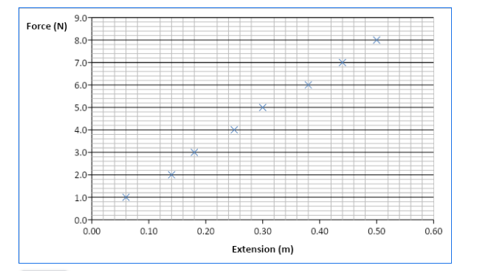
Gradient = ................................................................................................................................
- The graph below shows the motion of a runner for the first 40 seconds of a
race.
- What can you say about his speed? ........................................................................................................ ........................................................................................................
- Use the graph to find his speed at time 30s ..................................................................................................................................................................................................................................

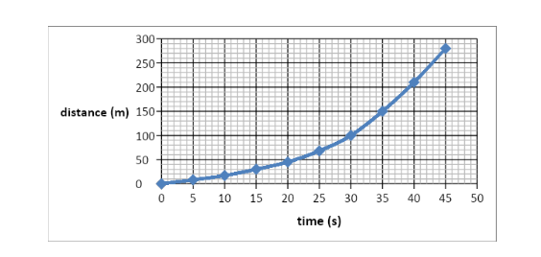

10. What can you say about the relationship between quantity a and quantity b?

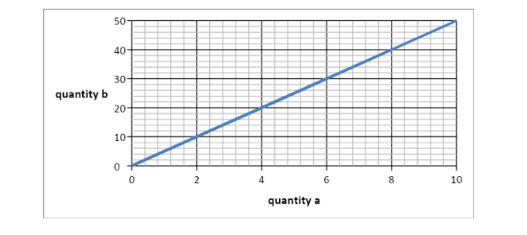
..................................................................................................................................................................................................................................................................

Using Formulae
- Find the answers to the following. Ensure you show all workings.
- PV = nRT
Find T if: P = 1700 Pa V = 3.0 V n = 2.5 R = 8.3
.......................................................................................................................................................................................................................................................................................................................................................................................................................................................................................................................................................................................................................................................................................................................................................................................................................................................................................................................................................................................................................................................................................................................................................................

- v² = u² + 2as
Find v if: u = 15 a = 1.5 s = 150 ....................................................................................................................................................................................................................................................................................................................................................................................................................................................................................................................................................................

- E_{k} = ½ mv²
Find v if: E_{k} = 1000 m = 170 ....................................................................................................................................................................................................................................................................................................................................................................................................................................................................................................................................................................

Pythagoras
- Find the length of the side labelled x:

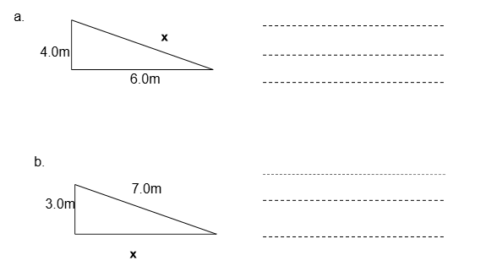

Trigonometry
- Find angle θ. The lengths of two sides are given.

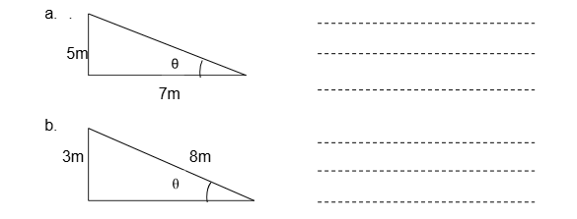

14. Find length x. The length of one side and one angle are given.

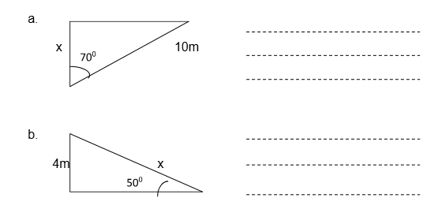
Uncertainty in experiments
A ruler is only accurate to the nearest millimetre so the distance 1mm larger or smaller than the measured value this 1mm error is known as the absolute uncertainty of the measurement this is written as ± 1mm.
Example 1.000 m measurement + 0.001m of uncertainty = Maximum value of 1.001m
15. A student uses a meter ruler to measure D and measures 0.895 meters. The ruler has an uncertainty of 0.001m.
What is the maximum distance possible? ………………………………….
What is the minimum distance possible? ………………………………….
16. The student uses the same meter ruler (uncertainty 0.001m) to measure the distance S1 and measures the distance as 91mm.
What is the largest distance for S1 possible? ………………………………….
What is the smallest distance for S1 possible? …………………………………..

17. What is the Percentage uncertainty for S1? ……………………………………
Example (For D)
(The uncertainty in the measurement) 0.001 x 100 = 0.1%
(the measurement) 1.000
Your Turn (For S1)
………………………………………………………………………………………………
……………………………………………………………………………………………..

- What is the percentage uncertainty of the following?
i) 6.8V ± 0.2V
………………………………………………………………………………………………
Answer: 6.8V ± ................................%
ii) 16.8m ± 0.2m
………………………………………………………………………………………………
Answer: 16.8m ± ................................%

Turn Over for Task 2

Task 2
Practical application of physics
Why is Diffraction seen with a
diffraction grating?

You need to research and produce a report on how a diffraction grating works.
The report must be about 300 - 500 words.
In your report you should include the keywords:
Diffraction, Phase, Antiphase, Constructive Interference, Destructive Interference, Superposition and Path difference.
- Introduction (which includes the aim of the report)
- Define each of the relevant specialist terminology (keywords) seen above.
- A suitable labelled diagram for constructive and destructive interference (which must be referenced in your report)
- An explanation of the physics principles involved in the experiment (Including an equation and what phase difference is required for constructive and destructive interference.)
- References / bibliography
The report can be handwritten, or word processed.
Videos that may help you:
Path Difference, Constructive & Destructive Interference - A Level Physics
https://www.youtube.com/watch?v=WRgf2r0WEHQ
Measuring Wavelength of Light with a Diffraction Grating - PRACTICAL - A Level Physics https://www.youtube.com/watch?v=TlkVtpzPTdU
Diffraction gratings
https://www.youtube.com/watch?v=WRgf2r0WEHQ

