
Year 11 > Year 12 Transition
Summer Term
AAQ Medical Science
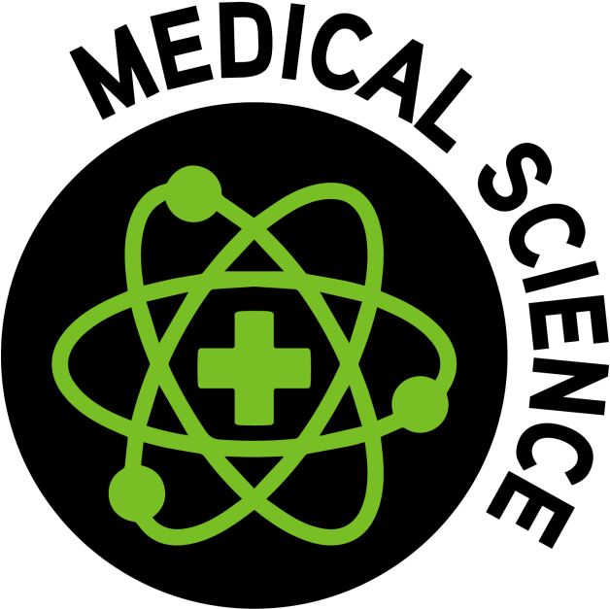

TABLE OF CONTENTS
Page No
 Course Overview 1-2

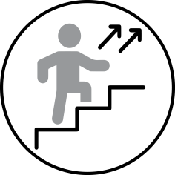 Our Expectations 3-4

 Using Cornell Notes 5

 Review / Revise 6

 Watch 7

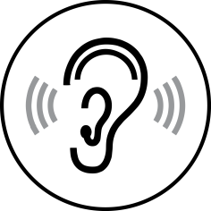 Listen to 8

 Read 9

 Research 10

 Complete 11

COURSE OVERVIEW

Course Title: Pearson Level 3 Academic Qualification BTEC National in Medical Science (Extended Certificate)
Exam board: Edexcel

What do Medical Scientists do?
Medical Scientists apply existing scientific knowledge to practical applications. This includes a broad range of related fields from health and medicine, business, to early childhood education. Medical Scientists also apply formal science, such as statistics and probability theory to analyse data and test hypotheses.
The AAQ Medical Science course covers a wide range of topics from cells structure to the heart and circulation, pathogens and the immune response to genetic disease and diagnostic testing in a healthcare setting, designed specifically to prepare learners for careers in the healthcare sector or further education.

What skills will I get from studying Medical Science?
As with the other sciences, Medical Science helps you to build up research, problem solving, organisation and analytical skills. You will also learn about a range of practical laboratory techniques, which will develop your practical skills, in particular, aseptic techniques and the safe culturing and identification of microbes.
If you study Medical Science, you will likely find yourself working on group projects, which will help you build your teamwork and communication skills too.

What careers can I do with Medical Science?
Medical Science is a key subject for lots of vocational careers, particularly in healthcare and jobs requiring practical skills.

Entry Requirements
It is recommended that students achieve a grade 5-4 in Combined Science and grade 4 in English.

COURSE OVERVIEW

Units studied
Unit 1 – Principles of Human Physiology, Anatomy and Pathology (External)
In this unit, students will study how the human body functions at a cellular and tissue level. Students will gain understanding of various organ systems that comprise the human body – nervous, endocrine, musculoskeletal, cardiovascular, respiratory, renal and digestive systems plus how they interrelate. It will provide students with a foundation for biological study in medical science.
Unit 2 – Health Issues and Scientific Reporting (External)
In this unit, students will explore a number of key areas in the field of medical science, with a focus on health issues faced by the human population today and explore the impact on the world we live in. Students will gain understanding of diagnostic techniques, before focussing on health issues alongside associated initiatives including cancer and various aspects of immune dysfunction, to the increasingly important world of genetics. This unit will provide students with the opportunity to interpret and analyse different forms of scientific information, and develop critical thinking and analytical skills.
Unit 3 – Microbiology and Infectious Disease
In this unit, students will investigate the effect of antimicrobial agents on the growth of microorganisms, by selecting and applying knowledge of microorganisms and infectious diseases. Students will draw on their wider scientific understanding and skills to plan and carry out a range of practical techniques. In this unit students will:
- Understand the classification and nature of microorganisms
- Examine the transmission and treatments of infectious diseases
- Explore the application of techniques to culture and identify microorganisms
- Investigate the effects of antimicrobial agents on the growth of microorganisms
And an optional unit.

Assessment
As with other AAQ qualifications, assessment is a combination of internally assessed assignments (coursework) and external exams.
Unit 1: Externally assessed written paper (1hr 30mins) on Human Physiology, Anatomy and Pathology.

Unit 2: Externally assessed written paper (2hrs) on Health Issues and Scientific reporting.

Unit 3: Internally assessed laboratory reports of Microbial Techniques and Investigations into Antimicrobial Agents.

Plus an optional unit.

OUR EXPECTATIONS

Expectations for Academic Success

The course teachers will work closely with all students and parents to create a purposeful, creative and stimulating environment in which students are encouraged to fully develop - both academically and personally.
We will expect you to take responsibility for your own behaviour and learning. Students should commit to:
- Ensuring academic success through regular attendance and punctuality at all required registrations, lessons and supervised study lessons.
- Completing all set tasks on time to the best of your ability, making full use of study periods and homework to enable you to meet all deadlines.
- Using study time effectively by bringing all required equipment and resources with you and making full and regular use of study periods, respecting the need for silent studying conditions.
- Working closely with all your teachers to develop an effective working relationship based on mutual respect and discussing your work with them on a regular basis and meeting targets set.
- Developing your skills as an independent, self-evaluative learner and work closely with your teacher in monitoring and discussing your academic progress. As an independent learner, if you miss a lesson, it is your own responsibility to find the teacher and catch up with the work missed.
- Organising your work efficiently and effectively into folders for each subject, making full use of individual subject expectations and using Cornell Notes daily to ensure work in your folders is relevant and meaningful.
- Attending all parents’ evenings with your teachers to discuss your progress and work.

OUR EXPECTATIONS

Course-specific Expectations for Academic Success
- Attend all lessons and be punctual.
- If you miss a lesson, speak to your teacher as soon as possible about the work missed and show evidence you have caught up by the following lesson.
- Complete extra notes during supervised study periods, as directed and bring evidence of these to the lessons.
- Complete homework tasks on time, these are often used in class during the following lesson.
- Maintain organised files and exercise books.
- It is imperative that you are organised and have good time management skills if you are to complete the coursework to a high standard.
- Deadlines for coursework must be adhered to.

USING CORNELL NOTES

The Cornell Notes system is a note-taking system devised by Walter Pauk, an education professor at Cornell University. It is a proven method that establishes a more effective learning process.

It is designed to help the user think and reflect upon the notes they have made as well as making them more useful for revision purposes.

Please click here to watch a video that explains how to take Cornell Notes properly.
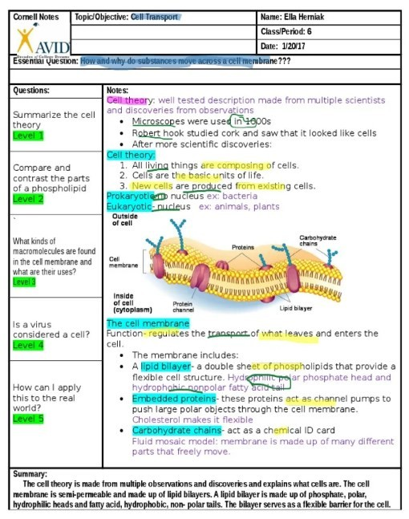
Here is an example of Cornell note taking in a Medical Science context.
Note the main body of the page has the notes taken in the lesson, questions are on the left and a brief summary at the bottom of the page.
The notes you take do not need to have levelled questions like in this example.

REVIEW / REVISE
You will need to make revision notes on the following topics using your GCSE revision guide and BBC bitesize.
- Cells structure, differences between plant, animal and bacterial cells
- Microscope, types of microscope and magnification, image, actual size calculations
- Enzyme action
- Diffusion, osmosis, active transport
- DNA structure, punnet square diagrams and inheritance
- The heart and circulation
- Health and disease, pathogens and the immune system

WATCH
All of life on Earth is made up using just four bases, which are used to create all the amino acids and all the proteins necessary for any form of life, from bacteria to humans. But what if we could make more bases? How many more amino acids and therefore proteins could we make and what could we do with them?
TED talk ‘Radical Possibilities of Man-made DNA’
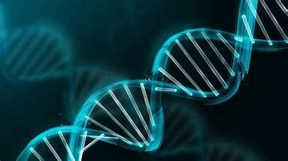
Watch and answer the following questions:
- What are the bases used in DNA?
- What names were given to the new bases made?
- What key attribute did the new bases have to have to be useable?
- How many natural amino acids are there?
- What are some of the possible uses of the extra proteins?
- Why would you produce a bacteria that glows green?
- Should we be worried about releasing new man-made forms of life into the environment?

If you like this, try some other TED talks:
The surprisingly charming science of your gut
The bacteria in your gut (your microbiome) is more important than previously thought and could have huge health implications.
Why is it so hard to cure HIV/AIDS?
Recently, an article described the first person to be cured of AIDS. How? And why has it taken so long?

LISTEN TO
Listen to the podcasts below and summarise one in a series of pictures, with a maximum of ten words.

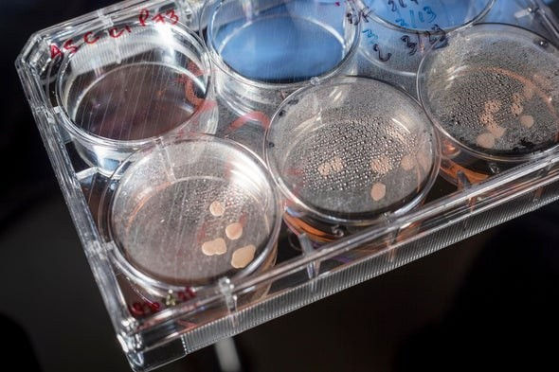
Lab grown human mini brains show brainy activity
Part of Scientific American’s ‘60second science’ series.

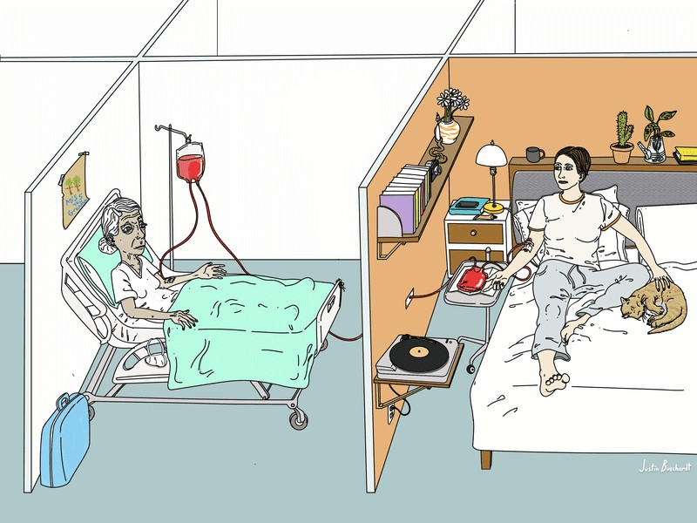
Shared Immunity (Radiolab)
Blood plasma transfusion is a century-old treatment but has begun trials across the world to treat Coronavirus. But how does it work?

If you like this, have a listen to:
Radiolab Really well produced, interesting and easy listening podcasts on loads of different science topics.
60 second science Short, sharp, to the point covering a wide range of themes.

READ
Choose one of the stories below and write a summary. What could be the impact of each of these stories on the future?

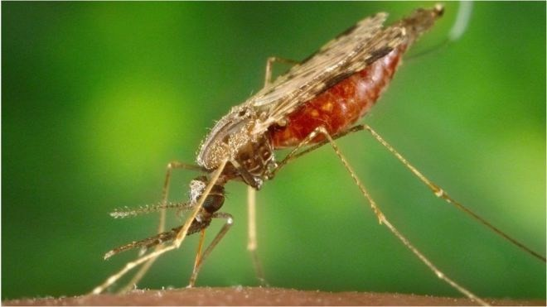

Malaria completely stopped by microbe
(BBC)

Profile of a killer: the complex biology powering the coronavirus pandemic (Nature)

Books you might be interested in:

- The Selfish Gene, Richard Dawkins
- The Blind Watchmaker, Richard Dawkins
- The Body: A Guide for Occupants, Bill Bryson
- Sapiens, Yuval Noah Harari
- The Immortal Life of Henrietta Lacks, Rebecca Skloot
- Fragile Lives, Stephen Westaby

RESEARCH
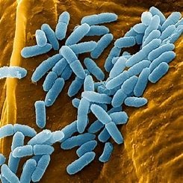
Research 1 disease caused by each of the following microorganisms:
- Bacteria
- Virus
- Fungi
- Protist

Answer the following questions about each disease:
) What are the symptoms?

) How does the micro-organism cause these symptoms?
) What are the treatment options available and how do they work?
) How successful are these treatments?

Present your findings as a booklet, poster or report (typed or handwritten), including pictures. You also need to reference where you got the information from with a separate section at the end of the report (entitled ‘References’). Any books you use (including textbooks), you must include the author surname, initial, title of book (in italics) and year of publication. For websites, you must copy the URL (not just the name of the website) and the date you accessed the site.

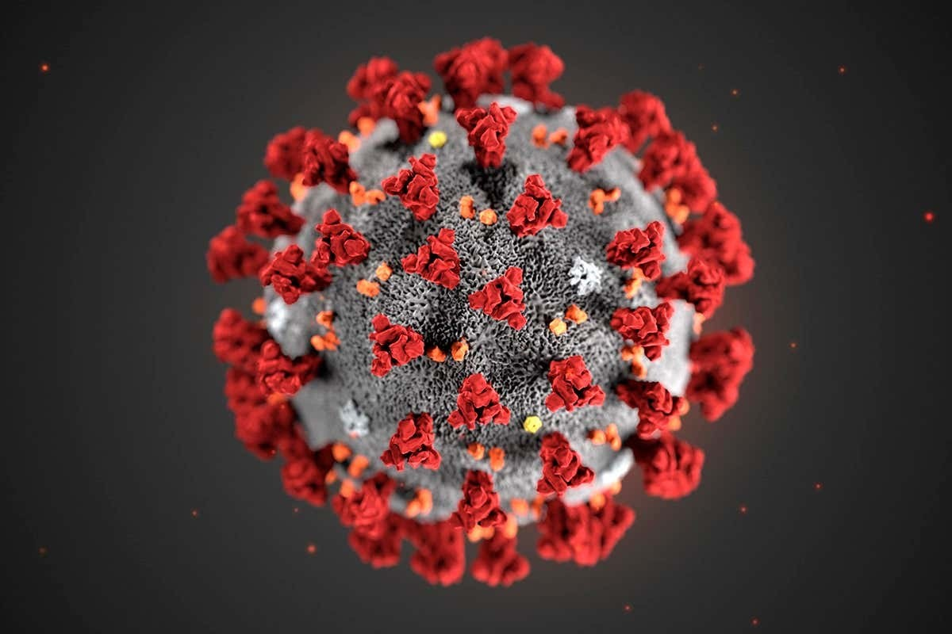
Click here for a video which has a good explanation of a commonly used system of referencing called Harvard referencing. You will need to use this system when completing your coursework.
Covid-19 Virus (computer animation)

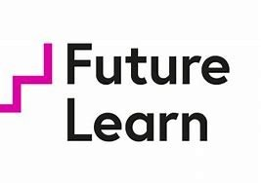
COMPLETE
The FutureLearn course below is all about cancer and genetic diseases. This links to unit 1, the exam unit which will cover a number of genetic diseases and their causes as well as the link between genes and cancer. This will also be good revision from your GCSE course.

Exploring Cancer and Genetic Disease

Complete the course and make Cornell notes on each section.

Others you might be interested in:
Understanding cardiovascular disease

