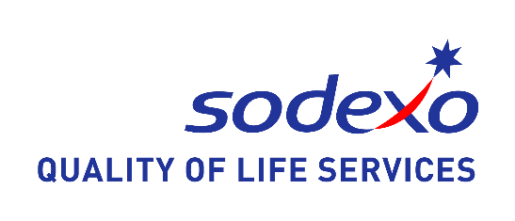

Dear Parent/Guardian,
You will be aware that food allergies are a growing concern in education establishments throughout the UK/Ireland. Individuals who are affected with a food allergy may suffer a severe or even life threatening reaction if they eat, or in some cases, simply come into contact with a food or ingredient that they are allergic to.
The health and safety of your child/young person is our number one priority. We need your help to ensure that we continue to provide a safe environment for your child/young person during meal times by completing and returning the food allergy information form in full and as soon as possible.
If your child/young person has a food allergy, we will need to share information about their food allergy with school staff and other external medical professionals. We will only use information that is necessary for your child/young person to receive a meal appropriate for their dietary needs. The dietary need will mean that Sodexo can only provide a plain jacket potato until results of testing are received. We can, however, suggest that you can provide your child with a packed lunch until the matter is resolved.
St. John’s/Sodexo will hold this information confidentially, it will be used by dieticians to determine which type of menu is appropriate for your child’s/young person’s dietary needs.
The information will not be used for any other purpose.
Please be aware that St. John’s/Sodexo will not be held responsible if forms are not completed and returned to the school.
Yours faithfully,

Aileen Thompson/Sarah Waller
Return to Learn / Medical Care Plan Coordinators
01474 534718 Ext 4088

