
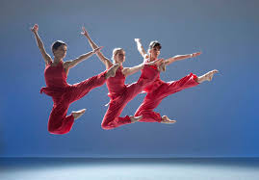
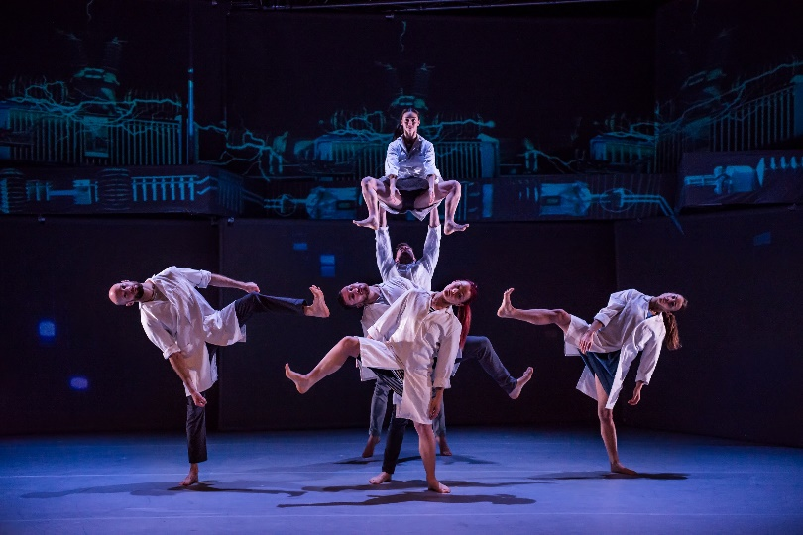
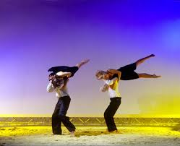
Activity Booklet

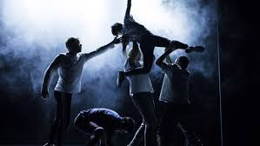
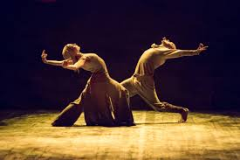
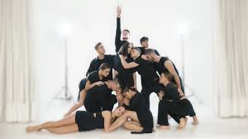

BTEC Level 3 Performing Arts: Dance

BTEC LEVEL 3 Performing Arts: Dance

Hello and welcome to your new course! We are so pleased and excited that you have chosen to study BTEC Level 3 Dance with us!
We know things are a little strange at the moment and really don’t want you to miss out whilst learning from home! So, we have put together an activity pack to keep you occupied and prepare you for the course on returning to school! All the activities are linked with the units you will complete once back at school or will help develop your skills and techniques further. We have tried to keep them fun and enjoyable too, we understand it’s not always easy working from home!

Here is just a little information about your course and what you can expect when we return:
The BTEC Performing Arts: Dance course is designed to develop students’ skills & techniques within a range of styles in order to progress into further education within the Arts or to the performance industry.
The course consists of both practical and theoretical units; for those of you who have undertaken BTEC Level 2, you will be familiar with logbooks and skills audits… it pretty much the same! You will have to do a number of presentations; these can be done in person or virtually! How cool is that! Your logs can also be vlogs, blogs or in a typed diary form. Now is the time to be ordering your nice folders, notebooks and new pens!
This booklet includes links to a lot of the professional works you will be studying throughout the course, again some you will be familiar with and some you may not have seen! Take this time to familiarise yourself with the works so when we return, we can crack on with the practical!
Please complete the booklet over the next few weeks, you should complete one activity per week, although some may take you a little longer!
We look forward to seeing you back in the studio soon!
Take care and stay safe!
Mrs Gibbons & Mrs Steadman

E -sgibbons@stj.kent.sch.uk



Week 1
Activity 1: The Who’s who of Contemporary Dance…

Task 1
Within the contemporary dance industry there are many famous choreographers. Some of these are pioneers of Dance; they reformed ballet and created the much-loved style of contemporary. Some take a more abstract approach to the style and some are just experimenting with connecting the body and mind as one…
Below we have named SIX choreographers which you need to research and create fact files for; all the information needed is also listed below!
Ensure these are detailed and informative as you will need to use these within your practice. We have also included a few interview, exercise clips or pieces for you to watch to give you an idea of their style and techniques.

Choreographers:
Merce Cunningham
Technique class: https://www.youtube.com/watch?v=kjGIj189fdM
Interview: https://www.youtube.com/watch?v=xJeum_kxSV8
Choreography: https://www.youtube.com/watch?v=ciBqm_XtYVE

Akram Khan
Technique Class: https://www.youtube.com/watch?v=GhAPWoub5rQ
Interview: https://www.youtube.com/watch?v=H8QTexyRn8k
Choreography: https://www.youtube.com/watch?v=72zQDL1hAJ0

Alvin Ailey
Technique class: https://www.youtube.com/watch?v=GqGqxINiBLU
Interview: https://www.youtube.com/watch?v=IcF9Dgke7uk https://www.youtube.com/watch?v=vumYpy_dD1c
Choreography: https://www.youtube.com/watch?v=BG1lg9GV9WY

Martha Graham
Technique class: https://www.youtube.com/watch?v=dX7YQxn7HVw
Interview: https://www.youtube.com/watch?v=dYYs5P-ccS4 https://www.youtube.com/watch?v=itKJXEoBWWg
Choreography: https://www.youtube.com/watch?v=OUpdAR4Hsuo

Matthew Bourne
Technique class: https://www.youtube.com/watch?v=wUPG-mE-Amk https://www.youtube.com/watch?v=Dcck9DuUNQ4
Interview: https://www.youtube.com/watch?v=7OhVld9iabA https://www.youtube.com/watch?v=Rja3uZy1tUk
Choreography: https://www.youtube.com/watch?v=RNazBK6rwrg https://www.youtube.com/watch?v=1jIeSq2FFhs https://www.youtube.com/watch?v=VikwwOcRONw

Richard Alston
Technique class: https://www.youtube.com/watch?v=SfZYp23SeRk
Interview: https://www.youtube.com/watch?v=6lUXFQpCAN8
Choreography: https://www.youtube.com/watch?v=4XnqJLBD4Lw&t=40s

Fact file information:
- Name
- Training – where did they train, what did they study
- Dance style/technique – what skill and techniques do they use? Explain their technique, what do they focus on, do they use specific things… contractions, straight lines etc.
- Company – name, aim, where is it based, do they have more than one element – main company, youth company, linked with a community project?
- Pieces/choreographies – explain how these may have been created
- Image of choreographer
- Famous for – what are they famous for? Creating something new, being the first to…, something they have said?
- Most famous piece – why, where was it performed, when was it created?

*Please set these out clearly and all in the same format, they must look professional!

Week 2

Activity 2: Move it, twist it, shake it, stretch it!

Task 1:
Watch the link below and follow the exercises shown… sounds easy enough!
Make sure you are listening to what the choreographer is saying about the use of the body; when to contract, stretch, breathe you’re your body positioning.
It’s really important that you embody the movement, this way you can really connect with the technique and understand how they go on to create their choreographies.
If you feel confident enough to, video yourself completing the lesson – this can be used as evidence for the course. If you are video shy, you could take some photos of the key positions within the exercises, these can be used within your evidence file too!
https://www.youtube.com/watch?v=6R6ntknWZcc

Task 2:
It’s your turn! Drawing inspiration from the exercise and technique you have just learnt; you are going to create your own (short) exercise which uses the whole body. The exercise should be performed on both sides of the body and should be roughly 2 minutes in total – of course it can be longer if needed. The idea of the exercises is that it warms up, mobilises and prepares your body for physical practice. Remember it must follow the same technique and style created by Martha Graham!
Here are a few more clips for inspiration:
https://www.youtube.com/watch?v=HViGAvqw1k8
https://www.youtube.com/watch?v=yY27QhNPAwQ
https://www.youtube.com/watch?v=NpIJPE5etdY

Task 3:
As a dancer and performer, your physical fitness is very important. Completing technique classes and attending rehearsals is not enough to maintain an ideal fitness, you have to undertake extra activities to ensure a high level of fitness, strength and stamina!
Watch the following videos…. Take notes on the exercises they are doing and what part of the body they are focusing on!
https://www.youtube.com/watch?v=sdZej7LNTIQ
https://www.youtube.com/watch?v=_6XWiSO_17I
https://www.youtube.com/watch?v=LRotEkoR9f0
https://www.youtube.com/watch?v=EzS0OQzOYjo
https://www.youtube.com/watch?v=dwfIgX6YKDc
https://www.youtube.com/watch?v=agMUF4HIwmM
https://www.youtube.com/watch?v=TqRDfn0L-Po
https://www.youtube.com/watch?v=njKwu3dqD0Y

Hopefully watching these gave you a good idea of the different types of workouts dancers and performers need to health, strong and physically fit!
So… you are going to create you own fitness workouts which you are going to do at least 3 times a week! You have no idea how hard we are going to work you when you get back!
Each workout should be at least 15 minutes long and shouldn’t necessarily need any equipment (weights etc – although a can of beans, big bottle of water or lifting a younger sibling may be useful)

Workout 1: Stretches
This workout should almost be a pre workout – workout! Or a ‘I’m broken, I can’t move’ workout for those days you are stiff like an ironing board from a hard workout the day before!

Workout 2: Cardio
The sweaty one… this should leave you red faced, sweaty and out of breath…all the things I know you hate!

Workout 3: HIT (High Intensity Training)
Short, sharp exercises create to have maximum impact…and absolutely kill!

In the templates below, fill in your own personalised workout. These must be realistic to you and what you can and will actually do! They are designed to improve your fitness, no one else’s…
Each template has an example exercise at the top to help you… please delete this an add another of your own! Each workout should have a minimum or SIX exercises!

Top tips:
- Remember with a stretch it needs to be held for 20 – 30 seconds to be effective
- They need to be performed on both sides of the body
- They are designed to warm and stretch the muscles gentle, each exercise should be repeated more than once to be 100% effective
- This workout could be used as a warm-up and cool down after a HIT or cardio workout
- If there is an area of the body you find particularly tense or lack flexibility, you might want to focus on this area.
- This is actually the workout I would do the most whilst at home… I don’t know about you, but I am getting serious ‘tech neck’ from sitting and staring at my laptop!
Workout 1: Stretches
Exercise | Time/Number of reps
Example: Shoulder stretch – reach R arm across the body, supporting with L arm and pull in towards the chest keeping R arm straight) this will stretch the arm and shoulder muscles. Repeat on L. | Hold each stretch for 30 seconds before swapping arms.  Repeat four times on each arm, each time trying to achieve a deeper stretch .

Top tips:
- Please remember to warm up before this workout!
- Each exercise should raise your heart rate…A LOT!
- This works well as a timed exercise – 30 seconds on, 30 seconds off…you can set a timer on your phones to help you!
Workout 2: Cardio
Exercise | Time/Number of reps
Example: Chest to floor burpees: jump up towards ceiling, arms stretched, on landing go into a crouch position, jump out into plank, perform a press up, jump legs back in to crouch position, start again! | 40 seconds on, 20 seconds rest, repeat five times

Top tips:
- Remember: SHORT, SHARP, SNAPPY!
- These work best with a high number of reps in a short space of time… 20 squats in 30 seconds, 15 push ups in 30 seconds… or you have 3 minutes to complete the following…
- Minimal rest time!
- This should almost be one continuous 15 minute workout!
Workout 3: HIT
Exercise | Time/Number of reps
Example 1: 20 sit ups, 15 press ups, 30 squats, 15 burpees, 20 v-Sits – repeat x2 | 5 minutes to complete all exercises
Example 2:  40 weighted sumo squats | 50 seconds, 10 seconds rest – repeat x 4

Week 3

Activity 3: Lights, Camera, Action!
This week’s activity is all about Matthew Bourne! His creativity, the costumes, the make up the theatre involved in his choreography and the famous mix of ballet and contemporary!
All of the tasks below are based on this clip. We have given the timings of the video we would like you to see but feel free to watch it all!
https://www.youtube.com/watch?v=1jIeSq2FFhs
Clip 1: 4:40 – 12:56 (orphanage)
Clip 2: 38:00 – 44:00 (frozen lake…with the pillow and feather!)
Clip 3: 51:00 – 1:01:00 (By invitation only)
Clip 4: 1:03:38 – 1:09:22 (wedding cake)

Task 1:
Answer the questions below. Your answers should be an analysis of the piece so make sure you are giving a detailed, factual answer…not just waffle or one word!
Orphanage section:
- Describe the children’s costumes within this section (the main children not the two who come on together).

- Explain why are the costumes all dark colours, adults and other children included…

- Describe the festive decorations used and why they might appear in this way…

- Describe the set within this section…

- Explain how the set and costume represents a certain era, decade or period of time…

Frozen Lake section:
- Explain what the oversized pillow and feather may represent…

- What stage effects are used to create the illusion of a frozen lake?

- Describe the costumes in this section…

- Analyse the movement within this section and explain its relevance to the idea of a ‘frozen lake.’

By invitation only section:
- Name the all the sweets within this section…

- Describe the styles of dance performed by each sweet…

- Explain how Matthew Bourne has used the sweets qualities to create his characters…. (think about their costumes, styles of dance, behaviour, movement, dynamics and even the music used for them!)

- Describe the set within this section…

Wedding Cake section:
- A lot of the movement within this section is based around eating or tasting the cake, describe the movements that could represent this idea…

- Describe the set within this section…

- Describe the lighting within this section…

- Describe the costume of the King and Queen of Candy Land…

Task 2:
Using the given templates, recreate the costumes of the listed characters… you can do this on the computer, print the templates or draw them on a separate piece of paper.
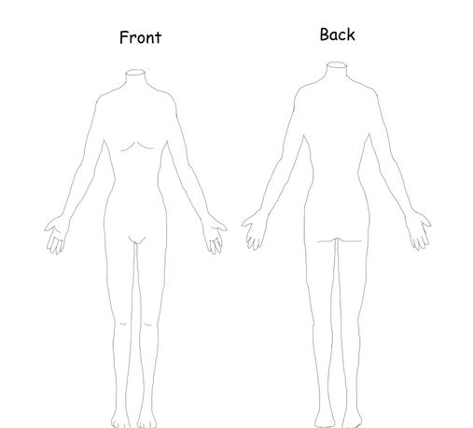

Cherubs

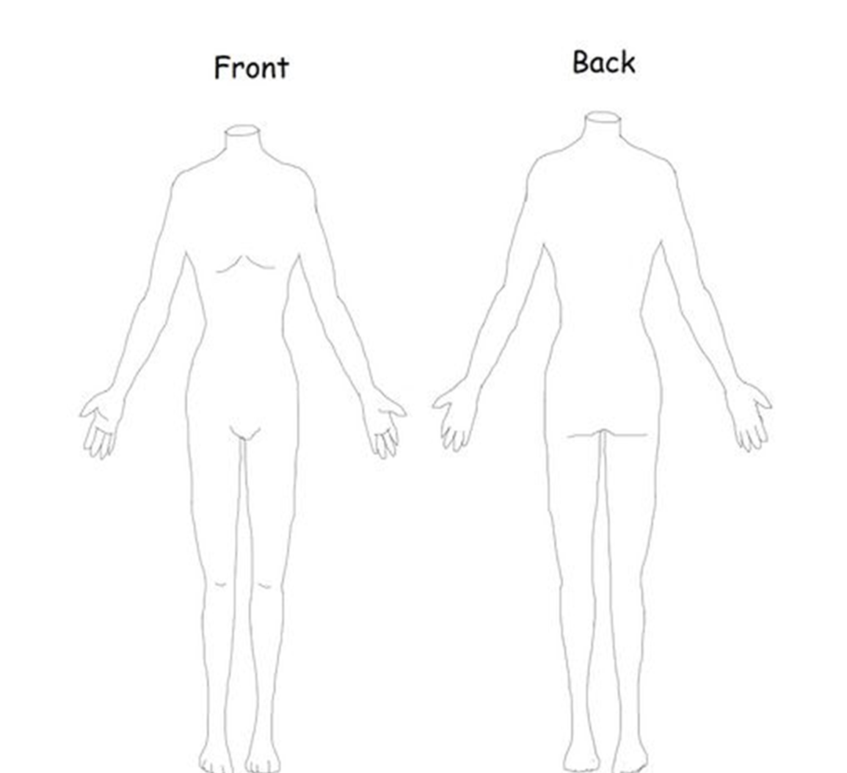

Mr Knickerbocker-glory

Clara

*pick one of Clara’s costumes to recreate above
Task 3:
For this task you are going to design your own sweet costume. The rules are as follows:
- You are not allowed to use a sweet that already appears in The Nutcracker!
- It must be in the colours of the chosen sweet or its packaging
- It needs to be a sweet NOT a chocolate bar!
- Think about the gender that may represent your sweet…is it gender specific?
- Try to incorporate the sweets ‘personality’ and ‘qualities’ within the costume.

Task 4:
Your fourth and final task is to create the set and lighting for one section of The Nutcracker!
This must include colour, and all details seen within the section – props included.
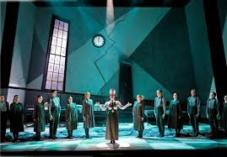
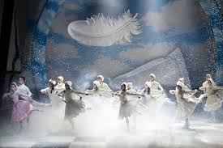
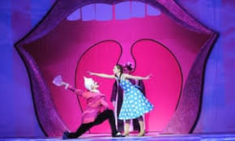
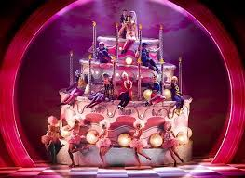
Again, you can do this using your computer/laptop or draw the design on a separate piece of paper.
Week 4

Activity 4: Audition preparation…
This week’s activity is all about preparing for an audition, both in a practical and theoretical way! You will need to create a range of material including a solo piece, a portfolio & a CV…. This work will be used within your evidence file for the course and will be super handy for those of you wanting to go into the profession! They will be ongoing documents which will be amended throughout the course.

The Richard Alston Dance company are looking for two dancers to join their prestigious company.
Auditions are to be held at The Place on the 9th May 2020 at 9am.
On arrival you must hand in your CV, portfolio and performance report. Your interview will take place after your practical audition.

Task 1:
Your first task is to create a solo inspired by one of Richard Alston’s choreographies. Your solo does not have to be created out of motifs, yet it should have a clear structure. You will need to choose an appropriate accompaniment; this should be without lyrics.
Things to think about when creating your piece:
- Stimulus – what is your chosen Alston piece about? How can you reflect that within your solo?
- You are trying to impress… show us what you can do!
- You are auditioning for a contemporary company…. Display this technique but add your personal flare to the movement.
- Take direct movements form the piece, this shows you have actually watched and analysed your stimulus!
- Action…
- Space…
- Dynamics…
- Relationships…

*Your choreography will be filmed on our return to school and will be used as evidence.

Task 2:
To accompany your solo you must write a ‘performance report.’ This is effectively a programme note, a short explanation of the piece, its inspiration, your creative process and choice of aural setting and costume. The report should be one side of A4.

Use the guide below to construct your performance report:

- Outline stimulus
- Explanation as to why you chose it
- How did you use the stimulus to create your piece?
- Creative process
- What did you want to show/represent?
- Explain your chosen costume – even if all black
- Explain aural setting

Task 3:
Using the template below, you must create a performance specific CV. Obviously at the moment you are still at school but you have had lots of performance opportunities, you will have gained qualifications within dance or performing arts already and are currently undertaking your Level 3 BTEC in Dance. You should also list workshops, auditions, dance lessons or any other dance related classes/workshops/performances you have been a part of. You will also need to write a personal statement and cover letter to accompany this.

These links may be useful when creating your CV & personal statement:
https://standout-cv.com/pages/dance-cv-example
https://www.resume-now.com/resume/examples/entertainment/dancer
https://expresscv.com/en?gclid=Cj0KCQjwhZr1BRCLARIsALjRVQN4gGUKoHi-A7thl1P2p-nK23j1K-juOnyXydyUs4LY2sMAcyl2w5gaAqmYEALw_wcB
https://www.oxbridgepersonalstatements.com/services/ucas-applicants/?gclid=Cj0KCQjwhZr1BRCLARIsALjRVQPwvNLHMt_uQ69KE7vP_U7i_OR4oZJ2_RwnguzxdMI5Oegskq_8w_4aAqnUEALw_wcB
https://www.ucas.com/undergraduate/applying-university/writing-personal-statement/personal-statement-the-killer-opening
https://auditionquest.co.uk/2019/10/04/how-to-write-a-dance-personal-statement/

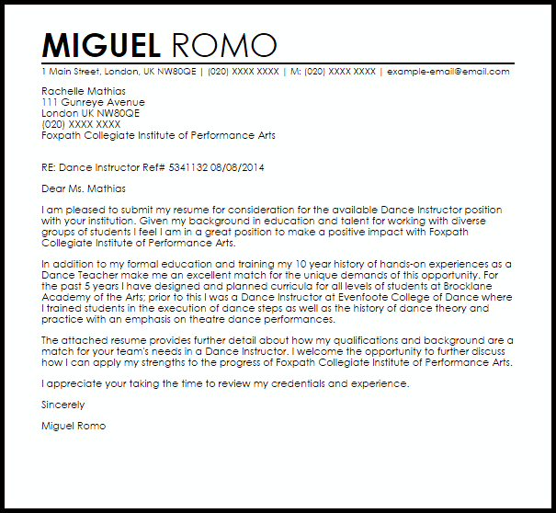
Cover Letter

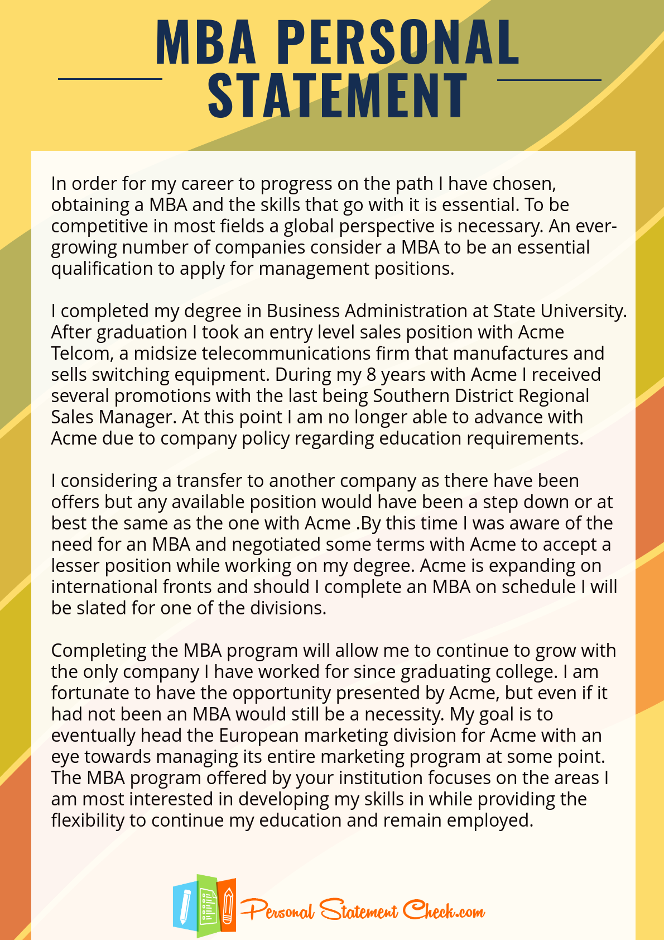
Task 4:
You must begin to build a portfolio of work for yourself, this can include headshots, grade certificates, programme notes/show programmes, images of you in performances, acceptance letters to workshops, summer schools etc and tickets to liver performances, workshops or dance specific events you have been to or undertaken.

You will need the following items for your return to school:
- Lever arch folder – the big one
- Dividers
- Highlighters
- Pens
- Pencil
- Plastic wallets
- Display folder – this is the one with the plastic wallets already included.

The must all be professional looking – no patterns, doodles or scribbles on them!

Week 5

Activity 5: Group choreography

This week’s task is all about creating a group choreography… a hard task whilst your at home but we can do it!
Our group piece is going to be based on Alvin Ailey’s piece – Revelations and performed to Wade in the water by Eva Cassidy - https://www.youtube.com/watch?v=9-hKDYQ6F54

Task 1:
Watch this clip for inspiration.
https://www.youtube.com/watch?v=RrPJ4kt3a64
make notes on the movements you like and those that really represent the theme of the piece. You must do your research on the piece and its stimuli!

Task 2:
You must create a section between 5 – 8 counts of 8 long inspired by Revelations. You can take sections and movements from the professional work, but your sequence must include some original material.

Task 3:
For this task you are going to plan how you are going to teach this on returning to school!
You must plan out the following aspects of your section:
- Entrances & exits
- No of dancers
- Partner work/contact?
- Spacing
- Pathways
- Dynamics
- Canon/unison
You must write all these elements down in order to help you teach your sequence.

Week 6

Activity 6: Articulation…
This activity is all about the contemporary dance pioneer Merce Cunningham and his theory on the five articulations of the spine…

Task 1:
List the five articulations of the spine according to Merce Cunningham
1.
2.
3.
4.
5.

Task 2:
Watch the following clip and try and identify the use of the spine.
https://www.youtube.com/watch?v=Jl9wr66eJes

Task 3:
Create a corner exercise the travels across the room moving through the five articulations of the spine. The sequence does not have to remain at one speed, it can vary.
Thinks to think about:
- Traveling
- Movements
- Positioning
- Heights
- Moving in and out of the floor
- Start & end
- music
The exercise should be performed one at a time so space shouldn’t be a problem.
*please video yourselves doing it as a reminder for when we get back to school – this way you wont forget it.
Week 7

Activity 7: The big one….
For this activity you are going to writing a report on the choreographer Akram Khan. This can be presented in either and essay format, as an article for a newspaper, create a PowerPoint presentation or as a blog/vlog. This will be used as evidence within your folder.

Task 1:
You must present the following information on the chosen choreographer:
- Summary of their work/style
- Dance/performance training
- Influences
- Their style – what is it, where does it come from?
- Choreographies – list a few, explain what they are about
- Creative process – how do they create their work…
- Who have they worked with, what impact has this had on their work/choreography
- Your favourite piece & why

You should include images and video links within your findings.

Think of this as a research information project where you are trying to explain to someone who knows nothing about dance Akram Khan’s way of working!



