English Language

Paper 1 and Paper 2

Revision Booklet



Please email Miss Gardiner if you have any questions: EGardiner@stj.kent.sch.uk

Paper 1 Section A Tasks
For this section of your language exam you will be asked 4 comprehension questions that will test your knowledge on language, structure and expressing your opinion in relation to a text.
Task 1:
Read through the following short extract.
So far they had been lucky. They had been attacked, of course, by leeches and mosquitoes and stinging ants. But the snakes and scorpions had left them alone. The rivers they had crossed had been free of piranhas. They had been allowed to survive.

List four things about how they survived.
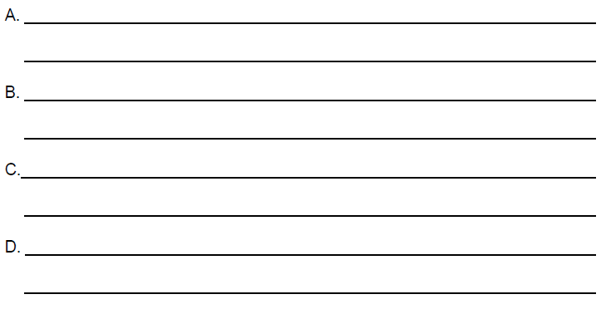
Task 2:
Read the following short extract.
Analyse and annotate the extract for the writer’s use of language in describing the forest.
Pick out any words and phrases, any language features and any sentence forms that you notice.
Consider the effect this description of the forest has on the reader.
...cutting their way through the dense, suffocating undergrowth, fighting through the very air, which hung heavy, moist and still. Trees tall as cathedrals surrounded them, and a strange green light - almost holy - shimmered through the vast canopy of leaves. The rain forest seemed to have an intelligence of its own. Its voice was the sudden screech of a parrot, the flicker of a monkey swinging through the branches overhead. It knew they were there.

Task 3:
Now that you have analyse the extract you need to be able to write your ideas into structured, well developed P.E.E.D paragraphs.
Point- Re-word the question and add in your idea/ statement.
Evidence- Select a quotation that matches your idea/ statement.
Explain- Explain what you quotation means and what feature of language is used.
Develop- Select a word or phrase from your quotation- comment on the effect this has on the rest of the sentence and the effect on the reader.
Example:
Point- The writer uses a long, almost list-like, opening sentence to add suspense and a sense of tension to the beginning of the extract.
Evidence- This creates a sense of danger, for instance “cutting their way through the dense, suffocating undergrowth, fighting through the very air”.
Explain- This suggests that whoever ‘they’ are, are in a fight against the forest to escape as the personified forest fights to keep them there.
Develop- The heavy adjective ‘dense’ and airless verb ‘suffocating’ add to the sense of suspense and danger as they describe a thick, overpowering atmosphere that surrounds the forest. This effects the reader, as they almost have to fight through the sentence to the very end, much like the characters in the extract, which again adds to the sense of danger and suspense.

Have a go at writing a P.E.E.D paragraph below. Remember to keep it structured, use quotations, comment on a word/phrase and comment on the effect on the reader.
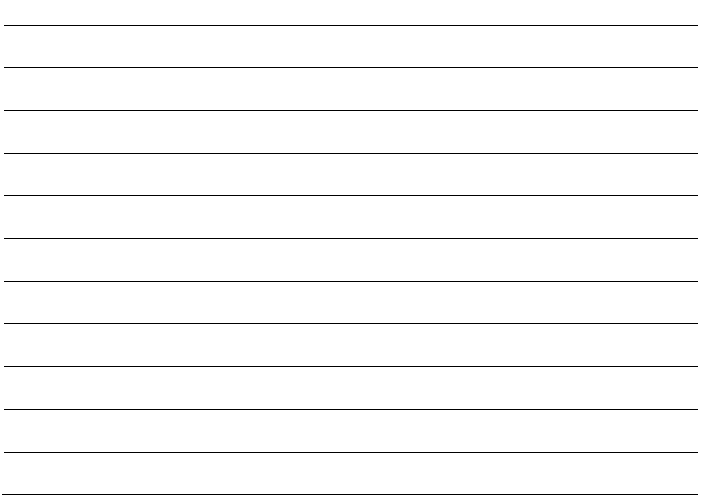

Task 4:
For Question 3 you are going to have to think about the structure of a text and how the writer develops/ shifts the focus from a setting/description/ or character to something else.
Below there is a shortened extract from the fairy tale ‘The Three Little Pigs’.
Once upon a time there were three little pigs. One pig built a house of straw while the second pig built his house with sticks. They built their houses very quickly and then sang and danced all day because they were lazy. The third little pig worked hard all day and built his house with bricks.
A big bad wolf saw the two little pigs while they danced and played and thought, “What juicy tender meals they will make!” He chased the two pigs and they ran and hid in their houses. The big bad wolf went to the first house and huffed and puffed and blew the house down in minutes. The frightened little pig ran to the second pig’s house that was made of sticks. The big bad wolf now came to this house and huffed and puffed and blew the house down in hardly any time. Now, the two little pigs were terrified and ran to the third pig’s house that was made of bricks.
The big bad wolf tried to huff and puff and blow the house down, but he could not. He kept trying for hours but the house was very strong and the little pigs were safe inside. He tried to enter through the chimney but the third little pig boiled a big pot of water and kept it below the chimney. The wolf fell into it and died.
The two little pigs now felt sorry for having been so lazy. They too built their houses with bricks and lived happily ever after.

Read through the extract and complete the following table:

 | What is happening? | Structural Features | What is the effect on the reader?
Beginning
Middle
End

Task 5:
Now consider writing this in a more formal way that is exam styled. Consider one of your ideas about how the piece is structured/ how the writer shifts the focus.
Write a P.E.E. paragraph (as modelled below) to comment on the effect the structure has on the text.
Remember to keep it structured, use quotations, comment on a word/phrase and comment on the effect on the reader.
P- In the beginning of the source the writer uses (structural features) when the writer describes (what’s happening).
E- This can be seen in the line (quotation).
E- This interests the reader because it makes them feel… because…
Task 6:
A student, having read the extract said: “The Three Little Pigs is all about work ethic (views on effort put into work). Two of the pigs are lazy and are punished while the third pig is rewarded for having put in the hard work.”
Below write down what you think about the statement above.
Do you agree/ disagree with what they have said? And why?
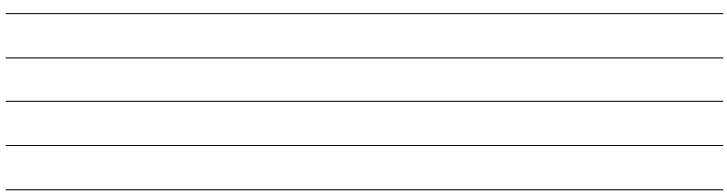

Task 7:
Now that you have consider how you feel about this statement- you now need to respond to the statement in relation to the text and your opinion.
I.e. Say that you agree with the statement you could write a paragraph about how much effort the third pig put into building his house. You would again need to use P.E.E.D but you would also need to include your personal opinion- whether you agree/disagree.
Remember to keep it structured, use quotations, comment on a word/phrase and comment on the effect on the reader.

Paper 1Section B Tasks
For this section of your language exam you will need to write an extended piece of description or the opening of a story which is inspired by a stimulus image. You will need to show your knowledge of using descriptive devices, structuring, vocabulary, and literacy skills.

Task 1:

One thing you want to avoid is writing which is dull and flat. One way to do this is to choose interesting words.

Try to avoid lazy words - these often come into your head first and we choose them because we can't be bothered to think of others. ‘Nice’ and ‘really’ are two of the worst.

Try to be as specific as you can in your word choice especially Verbs and Adjectives.

Pick the sentence which you think is more descriptive- and circle the words that improve it.

"We had a really nice dinner" "We enjoyed a tasty meal"

Task 2:

Rewrite the following sentences using more descriptive/ advance vocabulary:

The sky was black.

The sun shone on the colourful flowers.

The man appeared from nowhere.

Sadly, the rain continued.

The wave lapped the shore.

If you are struggling look at the website below.

http://www.enchantedlearning.com/wordlist/adjectives.shtml
Task 3:
Match up the language feature with the definition and example.
The words were music to her ears.
The parachute silk of his punctured lung.
I think of you a million times a day.
The man yelped in pain.

He is as quick as a fox.
The sky misses the sun at night.

States that something ‘is’ or that you are something.

The repetition of the same initial letter, sound, or group of sounds in a series of words.

The use of a word to describe or imitate a natural sound or the sound made by an object or an action.

A figure of speech in which human characteristics are given to an animal or an object.
Uses the words “like” or “as” to compare one object or idea with another to suggest they are alike.
An exaggeration that is so dramatic that no one would believe the statement is true.

Simile

Metaphor

Alliteration

Personification

Hyperbole

Onomatopoeia

Task 4:
Now write your own sentences using these language features:
Simile:
Metaphor:
Alliteration:
Personification:
Hyperbole:
Onomatopoeia:

Task 5:
You also need to be describing the 5 senses.
Sight- The glittering sun shone down upon the delicate petals of the pure white flower.
Sound- The birds chirped and whistled their cheerful tune.
Touch- Tiny blades of grass tickled the skin between my toes as I stepped across the lawn.
Taste- Dangling from a nearby tree and fresh juicy orange hung, waiting for its delicious syrup to be enjoyed.
Smell- The breeze carried the fresh scent of newly cut grass as it infused the air.

Read through the following extract- see if you can pick out which senses are used to describe the scene.
"He walked into the classroom and crossed to his desk. The floor was worn where years of boys had kicked and scuffed in their rush to escape. A damp, sickly-sweet aroma arose from the pile of jackets crushed in one corner and a blind tap, tapped against the window where a stone or ball had cracked the glass. Mr Jones rubbed his hands across the smooth polished top and examined his finger tips for dust."

Task 6:
Now try describing a winding day at the beach, make sure that you try to subtly use all 5 senses- try to avoid using the word ‘I’ as this will encourage you to varying your sentence starters.
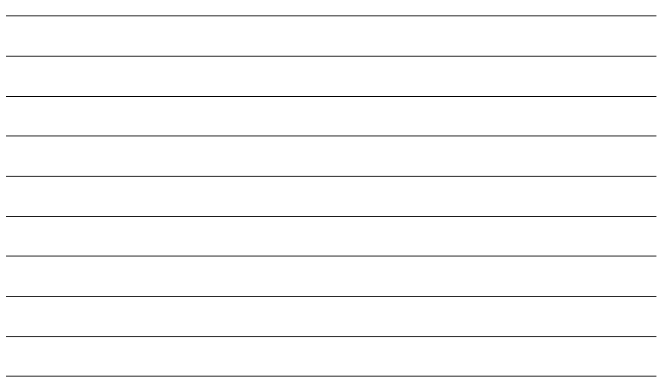
Task 7:
You also need to be varying your use of punctuation.
Commas
Use for a pause in a sentence
If you would finish eating your lunch, we could go outside.
Use to separate a list
I went to Morrisons and bought a sandwich, some crisps, a chocolate bar, and a banana.
Use to separate 2 parts of a sentence
While I finished my work, my friend made dinner.
Use a pair of commas to separate a less important piece of information
My teacher, Mr. Clark, is a great singer!

Now have a go at writing sentences using commas in the 4 different ways suggested above.

Apostrophes
Use it for belongings:
Individual- add ‘s
The bag belongs to Danielle- Danielle’s bag.
Plural ending in s- add ‘
The ball belongs to the 4 boys- The boys’ ball.
Plural not ending in s- add ‘s
The school belongs to the children- The children’s school.

Add apostrophes’ to the following sentences.
Whos the partys candidate for vice president this year?
The fox had its right foreleg caught securely in the traps jaws.
She did not hear her childrens cries.
My address has three 7s, and Tims phone number has four 2s.
Didnt he say when he would arrive at Arnies house?
Semi-Colon
The connective has been replaced with a semi-colon.
Shows that 2 ideas in one sentence are connected in some way.
I.e. We went to Spain for our holiday but the Grays went to Italy
We went to Spain for our holiday; the Grays went to Italy.

Rewrite the sentences below using a semi-colon.
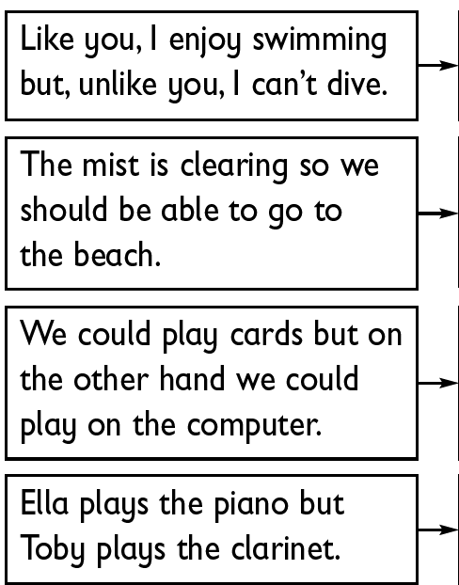

Question Marks and Exclamation Marks
Question marks highlight a question, whilst exclamation marks present shock, anger, and other forms of expressive emotion.
Look at the following sentences, add in either Question Marks or Exclamation Marks.

What’s the time
I’ve had such an amazing birthday
Did you hear that
Why are you shouting at me
I’ve done nothing wrong
Hey You can’t do that
Have you ever felt so peaceful

Task 8:
Using the Zoom-in technique can really add to your description. It can help to build tension, interest the reader, and help you to show off your descriptive skills.
Look at the image below- in order to make this sound much more than just a wave, you could Zoom-in on specific details to make the description more menacing or more descriptive.
I.e. The wave rose and rose until it stood dominating the rest of the ocean.
Zoom- in-
The water surged and the crystal like white wisps that flew off the menacing wave soared into the freezing air; the wave no longer dominated just the ocean. The droplets sprayed into the ferocious wind and became one with the sky. Quickly, they separated into minute fragments: there was no stopping them now.
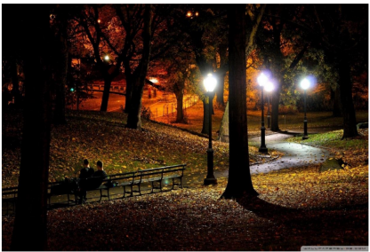
Now have a go at writing a paragraph using the Zoom-in technique using the second image as a stimulus. Think about describing the park and the lights before Zooming-in on the shadows or the couple sitting on the bench.

Task 9:
To really interest the reader you also need to be varying your sentence starters and sentence lengths. You can do this by using adverbs/ ‘ly’ words and by using short sentences to build tension/ for effect.
Adverbs
I.e. Quickly, the thieving boy raced away down the street.
Look at the sentences below, re-write them using adverbs to as sentence starters.
He looked at this watch
He peered round the edge of the doorway
They called the police
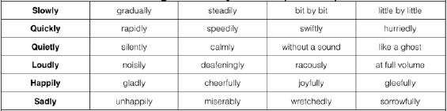
Short Sentences
You can use short sentences for effect or to build tension.
Look at the two sentences below. Identify which is which.
“Marley was dead: to begin with. There is no doubt whatever about that. This must be distinctly understood, or nothing wonderful can come of the story I am going to relate.”
Slowly, I walked. There was just the sound of my footsteps on the cold, hard ground. There was the crack of a great sound behind me. I stopped and turned…
Now try to write your own examples of the two forms of Short Sentences.

Task 10:
Now try to combine all of those skills- Look at the image below.
Make a plan of your ideas, what could you describe/how are you going to use all of those techniques.
5 Senses:
Sight:
Sound:
Taste:
Touch:
Smell:

:
:

Vocabulary/ Adverbs:

Punctuation:
;
( )
?
!

:
:

Language Features:
Simile:
Metaphor:
Alliteration:
Personification:
Hyperbole:
Onomatopoeia:

Plan
Zoom-in Technique:

Description Details:



Task 11:
Write a short descriptive piece using your notes from the task and image above.
Remember to vary your: punctuation, vocabulary, sentence starters, use of language features, use of the Zoom-in technique, description of the 5 senses and your use of sentence lengths.

Paper 1 Section A: Exam Practice
Source A
This extract is from the opening of the novel Pride and Prejudice by Jane Austin. Written in 1813 it is set in a time in which women and daughters were expected to marry in order to support the family- in this scene Elizabeth Bennet is describing the excitement of her mother as she realises that a rich gentleman has come to town, and her father’s react to her excitement.
Pride and Prejudice
It is a truth universally acknowledged, that a single man in possession of a good fortune must be in want of a wife.
However little known the feelings or views of such a man may be on his first entering a neighbourhood, this truth is so well fixed in the minds of the surrounding families, that he is considered as the rightful
5 property of someone or other of their daughters.
"My dear Mr. Bennet," said his lady to him one day, "have you heard that Netherfield Park is let at last?"
Mr. Bennet replied that he had not.
"But it is," returned she; "for Mrs. Long has just been here, and she told me all about it."
Mr. Bennet made no answer.
10 "Do not you want to know who has taken it?" cried his wife impatiently.
"You want to tell me, and I have no objection to hearing it."
This was invitation enough.
"Why, my dear, you must know, Mrs. Long says that Netherfield is taken by a young man of large fortune from the north of England; that he came down on Monday in a chaise and four to see the place, and was
15 so much delighted with it that he agreed with Mr. Morris immediately; that he is to take possession before Michaelmas, and some of his servants are to be in the house by the end of next week."
"What is his name?"
"Bingley."
"Is he married or single?"
20 "Oh! Single, my dear, to be sure! A single man of large fortune; four or five thousand a year. What a fine thing for our girls!"
"How so? How can it affect them?"
"My dear Mr. Bennet," replied his wife, "how can you be so tiresome! You must know that I am thinking of his marrying one of them."
25 "Is that his design in settling here?"
"Design! Nonsense, how can you talk so! But it is very likely that he may fall in love with one of them, and therefore you must visit him as soon as he comes."
"I see no occasion for that. You and the girls may go, or you may send them by themselves, which perhaps will be still better; for, as you are as handsome as any of them, Mr. Bingley might like you the
30 best of the party."
"My dear, you flatter me. I certainly have had my share of beauty, but I do not pretend to be anything extraordinary now.
When a woman has five grown up daughters, she ought to give over thinking of her own beauty."
"In such cases, a woman has not often much beauty to think of."
35 "But, my dear, you must indeed go and see Mr. Bingley when he comes into the neighbourhood."
"But consider your daughters. Only think what an establishment it would be for one of them. Sir William and Lady Lucas are determined to go, merely on that account, for in general, you know they visit no new comers. Indeed you must go, for it will be impossible for us to visit him, if you do not."
"Mr. Bennet, how can you abuse your own children in such way?
40 You take delight in vexing me. You have no compassion on my poor nerves."
"You mistake me, my dear. I have a high respect for your nerves. They are my old friends. I have heard you mention them with consideration these twenty years at least."
"You are over-scrupulous, surely. I dare say Mr. Bingley will be very glad to see you; and I will send a few lines by you to assure him of my hearty consent to his marrying which ever he chooses of the girls; though
45 I must throw in a good word for my little Lizzy."
"I desire you will do no such thing. Lizzy is not a bit better than the others; and I am sure she is not half so handsome as Jane, nor half so good humoured as Lydia. But you are always giving her the preference."
"They have none of them much to recommend them," replied he; "they are all silly and ignorant like other girls; but Lizzy has something more of quickness than her sisters."
50 "Ah! You do not know what I suffer."
"But I hope you will get over it, and live to see many young men of four thousand a year come into the neighbourhood."
"It will be no use to us if twenty such should come, since you will not visit them."
"Depend upon it, my dear, that when there are twenty I will visit them all."
55 Mr. Bennet was so odd a mixture of quick parts, sarcastic humour, reserve, and caprice, that the experience of three and twenty years had been insufficient to make his wife understand his character. Her mind was less difficult to develop. She was a woman of mean understanding, little information, and uncertain temper. When she was discontented, she fancied herself nervous. The business of her life was to get her daughters married; its solace was visiting and news.
Fortune- Wealth
Netherfield Park- Stately home in the country
Chaise- Horse and Carriage- for those who were wealthy

Paper 1 Section A

Exam Practice- Questions
Question 1- Read again the first part of the source- lines 1 to 5
List four things from this part of the text about societies view on marriage and wealth.

Question 2- Look in detail at this extract from lines 12 to 21.
"Why, my dear, you must know, Mrs. Long says that Netherfield is taken by a young man of large fortune from the north of England; that he came down on Monday in a chaise and four to see the place, and was
15 so much delighted with it that he agreed with Mr. Morris immediately; that he is to take possession before Michaelmas, and some of his servants are to be in the house by the end of next week."
"What is his name?"
"Bingley."
"Is he married or single?"
20 "Oh! Single, my dear, to be sure! A single man of large fortune; four or five thousand a year. What a fine thing for our girls!"

How does the writer use language here to describe how desirable a match this young gentleman would be for a women?
You should include the writer’s use of:
- Words and phrases
- Language features and techniques
- Sentence forms

Question 3-You now need to think about the whole of the source.
This text is from the opening of the novel.
How has the writer structured the text to interest the reader?
You could write about:
- What the writer focuses your attention of at the beginning
- How and why the writer changes this focus as the extract develops
- Any other structural features that interest you

Question 4- Focus this part of your answer on the second half of the source, from line 23 to the end.
A student having read this section of the text said: “The writer brings the very different characters to life for the reader. It is like you are sitting in the parlor with them”
To what extend do you agree?
In your response, you could:
- Write about your own impressions of the characters
- Evaluate how the writer has created these impressions
- Support your opinions with quotations from the text

Paper 1 Section B

Exam Practice- Questions
Section B:
You are advised to spend about 45 minutes on this section.
Write in full sentences.
You are reminded of the need to plan your answer.
You should leave enough time to check your work at the end.
0 5
You are going to enter a creative writing competition.
Your entry will be judged by a panel of people of your own age.
Either:
Write a description suggested by this picture:
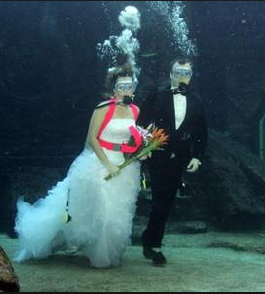
Or:
Write the opening part of a story about an unusual wedding.
(24 marks for content and organisation
16 marks for technical accuracy)
[40 marks]

Paper 2 Section A Tasks
For this section of your language exam you will be asked 4 comprehension questions that will test your knowledge on language.

Task 1:
Read through the following sentences.
A would-be robber who tried to carry out a raid at a jeweller’s while dressed in women’s clothing has been jailed. Footage released by police shows Ryan Valentine, 39, entering the shop wearing a long dark wig, a pair of sunglasses and a black skirt.

Circle the True statement.
- A robber wearing women’s clothing has not been jailed.
- He was wearing a dark wig and a black skirt.

Task 2:
Read through the following extract.
In 2012 around 100 chimps were retired from research facilities to Chimp Haven but hundreds of chimps, including those privately held, remain in captivity. In June, the US Fish and Wildlife Service decided to list chimpanzees as endangered, which restricts most invasive research on the animals. There have also been recent court cases launched in the US to grant chimps legal rights, similar to humans.

Write two more bullet points, like the one below, that sum up what is being discussed in the extract above.
- 100 chimps were retired from research, more remain in captivity.

Task 3:
Now that you have summarised one text you need to be combining it with another summary (Source A and Source B).

Again look at the extract below. Write two more bullet points, like the one below, that sum up what is being discussed in the extract above
A contract testing laboratory called BIOQUAL (formerly known as SEMA) tormented them in NIH-funded experiments on hepatitis C and placed swarms of mosquitoes on them to infect them with malaria. After learning that BIOQUAL was separating young chimpanzees from their mothers, locking them in individual cages, infecting them with norovirus—which causes diarrhea, vomiting, and stomach pain—and then subjecting them to months of painful biopsy procedures, PETA purchased stock in the company to urge it to phase out the use of chimpanzees and called on NIH to cut funding for the experiments.

Task 4:

Now that you have picked out the extracts main points consider your ideas in relation to the following question.
Summarise how the writer feels about the rights for Chimpanzees are changing.

You need to write your answer as a P.E.E.P.E.E. paragraph but you also need to ensure that you are generalising your ideas and are writing about both texts in one paragraph.
Point- Re-word the question and add in your idea/ statement.
Evidence- Select a quotation that matches your idea/ statement.
Explain- Explain what you quotation means.
Example:
Point- Source A suggests that rights for Chimpanzees are changing, but that they are not necessarily changing fast enough as they continually refer to the negative treatment of Chimps.
Evidence- For instance, “but hundreds of chimps…remain in captivity.”
Explain/ New Point- This suggests that the writer feels frustrated at the slow pace or insignificant changes to the Chimps rights. On the other hand, Source B, presents the horrific treatment of the Chimps.
Evidence- For example, “and then subjecting them to months of painful biopsy.”
Explain- This suggests that perhaps the writer feels that their rights are not being adhered to.

Task 5:
Read through the advertisement below.
Welcome to the Walt Disney Studios Park… Where it’s lights! Camera! Magic! Everywhere! All the time!
Step through the Studio gates and let your imagination soar. Time to immerse yourself in the never-ending, always fascinating world of movies, animation and television.
Four production zones within the park-featuring rides, show and entertainment with one single focus; entertainment for the whole family.

Make a list of language techniques that the writer uses to persuade costumers and families to go to Disney Studios Park. Back these ideas up with a quotation or example. Consider the use of personal pronouns, imperative verbs (bossy verbs), positive connotations/meanings, rule of three, and hyperbole.
- Direct Address- “Welcome”

Task 6:

Now that you have analyse the extract you need to be able to write your ideas into structured, well developed P.E.E.D paragraphs.
Point- Re-word the question and add in your idea/ statement.
Evidence- Select a quotation that matches your idea/ statement.
Explain- Explain what you quotation means and what feature of language is used.
Develop- Select a word or phrase from your quotation- comment on the effect this has on the rest of the sentence and the effect on the reader.
Example:
Point- The writer uses direct address to persuade the reader as it makes the advertiser feel relatable, reliable, and inviting.
Evidence- For instance “Welcome to Walt Disney Studios Park”.
Explain- This suggests to the audience that Walt Disney is almost personally inviting them, and this allows the audience to relax and rely on the information being presented.
Develop- The inviting exclamation ‘Welcome’ is also very upbeat and gives the advert a positive start on which to continue. However, this could also be considered as somewhat false and ‘overtly cheery’ as they are only interested in the customers money.

Consider how the writer uses language to persuade the audience to go to Disney Studios.

Task 7:

You are now going to have to compare the Disney advertisement with this negative review of a holiday.
Consider the following question as you Analyse the extract below.

Compare how both extracts refer to holiday experiences.

“What an utter disgrace it would be to find something truly magic and spend any time at all pretending and trying to convince yourself it is all just an unbelievably orchestrated and beautifully choreographed illusion.”

Task 8:

Now that you have analysed the negative extract and the Disney advertisement, you need to match up your ideas so that they link/ refer to similar/contrasting ideas.

I.e. First extract is very positive, ‘welcomes’ the audience- Second extract is very negative begins with an expressive ‘an utter disgrace’.

Task 9:

Consider the following question.

Compare how both extracts refer to holiday experiences.

Like the summary question you need to be combining both arguments into one paragraph. However, you need to go into more detail.
Example:
Point- In extract A the writer is persuasive and incredibly positive from the very first sentence, whereas extract B is incredibly negative.
Evidence- In extract A the writer “Welcomes” the audience to their holiday experience. In comparison, extract B begins with an overtly negative statement “an utter disgrace”.
Explain- This suggests that due to the persuasive nature of extract A the writer has attempted to seem upbeat and relatable, whereas, in extract B the writer is attempting to be frank/ incredibly honest about their experience.
Develop- The shameful noun “disgrace” is negatively connoted and carries a sense of bitterness on behalf of the writer and therefore suggests that, not only did they have a bad experience, but one that has left a lasting impression. The word “Welcome” on the other hand is very charming and inviting, and therefore poses as a direct contrast to the experiences in extract B.

Paper 2 Section B Tasks
For this section of your language exam you will need to write an extended piece of non-fiction which is inspired by a statement. You will need to show your knowledge of using persuasive, informative, instructive and descriptive devices, structuring, vocabulary, and literacy skills.

Task 1:

Below there are a number of Non-fiction forms.
You need to match up the form with the key features. Once you have done this you need to
- the use of a simple title
- a clear/apt/original title
- a strapline
- subheadings
- an introductory (overview) paragraph
- effectively/fluently sequenced paragraphs.
- a simple introduction and conclusion
- an effective introduction and convincing conclusion
- effectively/fluently linked paragraphs to sequence a range of ideas.
- the use of addresses
- a date
- a formal mode of address if required e.g. Dear Sir/Madam or a named recipient
- effectively/fluently sequenced paragraphs
- an appropriate mode of signing off: Yours sincerely/faithfully.
- the use of a simple title
- a clear/apt/original title
- organisational devices such as inventive subheadings or boxes
- bullet points
- effectively/fluently sequenced paragraphs.
- a simple address to an audience
- a final address to an audience.
- a clear address to an audience
- effective/fluently linked sections to indicate sequence
- rhetorical indicators that an audience is being addressed throughout
- a clear sign off e.g. ‘Thank you for listening’.

Letter

Article

Text for a leaflet

Text of a speech

Essay

Task 2:
Select at least two of these non-fiction forms (preferably forms that you are unsure of). If you still feel unsure, do some research and perhaps find an example.
Then write an opening paragraph to the forms that you have selected using these features.

Task 3:
You also need to consider the way you write as you also need to fit in as many language features as you can (at least 2 per paragraph).
Look at the language features, definitions and examples below- match them up.
It’s fast, fun and easy.

She sells sea shells on the sea shore.

97% of teenagers would use this.

It really is the biggest and brightest thing I’ve ever seen in the whole world!
Would you let your child drink dirty water?
The best colour is pink.

9 out of 10 cats prefer Whiskers
The child had been left for days with no food or water.
It’s free free free!

Statistics

Repetition

Hyperbole

Facts

Rule of Three

Opinion

Rhetorical Questions

Alliteration

Emotive Language

Questions that do not require an answer, made to make a person think

Words that provoke emotions in the reader

Using the same words or phrase over again

Something that somebody thinks or believes

Exaggeration

Using three points to support a point of view

Figures used to support point of view

Something that is true and can be proved

Using the same letter or sounds in a series of
Words

Task 4:
Now try using at least 4 of these language features below- try to use them in a persuasive, informative, instructive or argumentative way.

Task 5:
You also need to ensure that you are using more advance punctuation to ensure that you also achieve a good mark out of 16 for your Spelling, Punctuation and Grammar.
Read through the rules of the punctuation below- these can be used to vary your punctuation with effect.

Brackets
Use brackets to enclose information that clarifies or is additional to the sentence.
I.e. He finally answered (after taking five minutes to think) that he did not understand the question.
Now write your own example of a sentence that uses brackets.
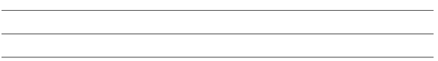

Semi-Colon
The connective has been replaced with a semi-colon.
Shows that 2 ideas in one sentence are connected in some way.
I.e. We went to Spain for our holiday but the Grays went to Italy
We went to Spain for our holiday; the Grays went to Italy.

Rewrite the sentences below adding in a semi-colon to vary punctuation.
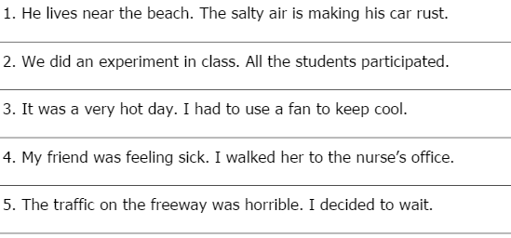
Task 6:
In order to really succeed in this section of the exam you need to be considering the structure of your work and the effect this has on the reader.
I.e. if a piece is unstructured, the reader can become confused and lost within your
writing.
Whereas if a piece is well structured, the reader is lead from point to point and
will feel as though they have been guided through something.

The best way to ensure that your work is structured is to plan each paragraph roughly.
I.e.
Paragraph 1: Introduce subject- any key pieces of information to help the reader understand/ summarise the topic.
Paragraph 2: Include more details to flesh out the subject that you outlined in the first paragraph- being to include your ideas/ first points.
Paragraph 3: Move onto your next idea/ point- this must be
Paragraph 4: This should be your final and most powerful idea/point.
Paragraph 5: Treat this like a summary, and summarise your ideas, also end on something powerful.

Imagine that you have been asked to write a speech about the current state of the food available at lunch. Plan out your ideas like I have above, in brief/ bullet-point-like sentences to help you structure your work. Make sure that it flows and that your arguments build.

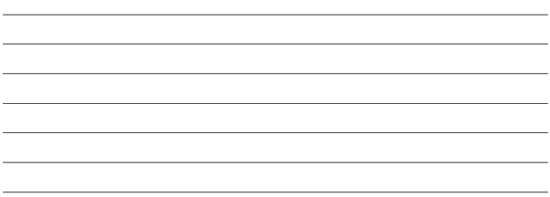

Task 7:
This question will require you to comment on a statement, therefore you need to be able to present similar and different viewpoints whilst focusing on the form of writing.

Below there are a number of statements- underneath make a list of points/ ideas that spring to mind- remember to also look at contrasting views to your own.

I.e. “Homework has no value. Some students get it done for them; some don’t do it at all. Students should be relaxing in their free time.”

Agree- students are overworked and stressed. Not all do the Homework, so for some it is pointless. Sometimes is irrelevant and just for the sake.
Disagree- It can help boost grades. Some enjoy independent work.

“Year 1 students are now sitting a SPaG test that even degree level adults would struggle with! Are they not allowed to be Children?”
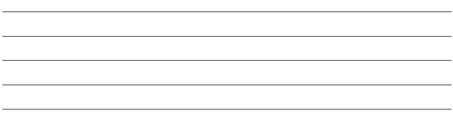

“Music is disruptive and unsettling. Listening to it can cause many students to lose focus; this is why we don’t allow it in schools.”

“The death penalty should be brought back for those who commit horrific crimes.”

“I’m 25 and I can’t afford to buy a house where I grew up. The prices have risen so much and people from London are now moving further afield to cut their costs that I have been priced out of my childhood memories. Why won’t the Government do something to help?”

Task 8:

“Life is like a box of chocolates. But if you’re rich you get the whole box.”

Write a Non-fiction Essay in which you argue your point of view on this statement.
Remember to plan your answer, use language features and vary your punctuation.

Paper 1 Section A: Exam Practice

Source A

Libby Purves’ Review of The National Theatres Play Frankenstein- for The Times 2011
A great bell calls silence. The Olivier is a dim red womb, pulsing with threat: overhead a mass of lights and tubes shimmer. A shadow rips through a membrane to become a bloody, scarred, naked man, racked by spasms of unfamiliar muscle. A baby learns movement sweetly by degrees, strength coming slowly, but this new-born adult has to struggle with horrible kicks and tremors to
5 find uprightness. Abandoned, he wanders through an incomprehensible world where crowds mill
and shriek and a huge, terrible machine roars towards us on rails from nowhere: a surreal caricature of industrial England. He flees. In wider fields the amazing sun rises, grass grows, larks fly upwards, fire burns, rain cools. All is new.
We are required to feel the dazzle and terror that the Creature endures, for in this adaptation of
10 Mary Shelley’s novel, too long vulgarised into horror films and monster cartoons, the writer, Nick
Dear, and director, Danny Boyle, come fresh to the wonder and fear of it by taking the Creature’s point of view. If he is a monster, it is only because he meets abuse and blows.
It is a hell of a production: the set itself conveys unease, rising and revolving into harsh surprises. But it is the Creature that mesmerises, developing a jerky, defective, heart breaking eloquence as
15 ideas and desires invade him. The two leading parts, scientist and creature, alternate night by
night and critics were asked to see both versions. First Benedict Cumberbatch was Victor Frankenstein, and Jonny Lee Miller appallingly brilliant as the Creature. That felt cast to type: Lee Miller animalistic, physically expressive, plaintive, primitive; and Cumberbatch, who without much trouble can always give us a scholarly, arrogant toff in a frock coat. Yet, the next night,
20 Cumberbatch astonished in the monster role, moving into a zone of physical expressiveness and
otherness we have never yet seen; and his scenes with Lee Miller’s tougher, hoarser Frankenstein worked even better than the first way round, through anger and argument to the ultimate, deep-damned unity of their flight to the magnetic, electric North Pole.
This taut, thrilling play runs to its awful conclusion without an interval, indeed with hardly a moment
25 for breath. Yet it remains, as Mary Shelley intended, basically a work of philosophy, pathos and
moral seriousness. In his brief experience of kindness from blind old De Lacey (a lovely, gentle performance by Karl Johnson) the Creature, taught to read Milton and Plutarch, cries: “Ideas batter me like hailstones. Who am I?”
He struggles with identity, with physicality, with knowing himself to be a thing galvanised by the new
30 power of electrochemistry out of dead organs “stolen at night from wet soil, meat for dogs”. He is
disabled by his lack of memory, baffled by mankind. Why do we herd together in cities for mutual help yet massacre one another, he asks. “I do not like inconsistent! Why must it be so?” Nameless, rootless, he is the ultimate exile. “Why do you know everything and I nothing? I am the one who stands outside the door.” Meeting hostility, he learns revenge; reading poetry, he dreams of love.
35 Tracking down his elusive dilettante of a maker, in sharply funny confrontations with Victor
Frankenstein, he pleads for a companion, a woman-thing like himself. His ruthlessness grows with rejection, stance and face hardening, losing their bloodied, baffled innocence.
Mark Tildesley’s stunning design and Bruno Poet’s remarkable lighting effects use the Olivier’s vastness with controlled, imaginative strength. The music, by Underworld, is perfect. Naomie Harris
40 is calmly touching as Elizabeth, Victor’s fiancée, and Ella Smith (British theatre’s top wench ’n’
trollop interpreteuse) is grand in her two quick cameos. The only jarring element is George Harris as Frankenstein’s father — a fine actor normally, but in this case disastrously uneasy with Victorian-melodramatic lines such as: “You flout my authority. In short, you disappoint me.”
Otherwise, it is rather wonderful: thoughtful, exciting, moving. At the 1823 dramatised version,
45 ladies fainted in the stalls and critics thundered: “Do not take your wives and daughters!” We think
we’re tougher now, but I nearly fell out of my seat at the shock bridal-chamber scene. Twice.

Source B

Percy Bysshe Shelley’s Review of Frankenstein: Or, The Modern Prometheus (written in 1818 by Mary Shelley (Shelley’s wife) for The Athenæum, 10 November 1832
The novel of 'Frankenstein; or, the Modern Prometheus,' is undoubtedly, as a mere story, one of the most original and complete productions of the day. We debate with ourselves in wonder, as we read it, what could have been the series of thoughts—what could have been the peculiar experiences that awakened them—which conduced, in the author's mind, to the astonishing combinations of
5 motives and incidents, and the startling catastrophe, which compose this tale. There are, perhaps,
some points of subordinate importance, which prove that it is the author's first attempt. But in this judgment, which requires a very nice discrimination, we may be mistaken; for it is conducted throughout with a firm and steady hand. The interest gradually accumulates and advances towards the conclusion with the accelerated rapidity of a rock rolled down a mountain. We are led breathless
10 with suspense and sympathy, and the heaping up of incident on incident, and the working of
passion out of passion. We cry "hold, hold! enough!"—but there is yet something to come; and, like the victim whose history it relates, we think we can bear no more, and yet more is to be borne. Pelion is heaped on Ossa, and Ossa on Olympus. We climb Alp after Alp, until the horizon is seen blank, vacant, and limitless; and the head turns giddy, and the ground seems to fail under our feet.
15 This novel rests its claim on being a source of powerful and profound emotion. The elementary
feelings of the human mind are exposed to view; and those who are accustomed to reason deeply on their origin and tendency will, perhaps, be the only persons who can sympathize, to the full extent, in the interest of the actions which are their result. But, founded on nature as they are, there is perhaps no reader, who can endure anything beside a new love story, who will not feel a
20 responsive string touched in his inmost soul. The sentiments are so affectionate and so innocent—
the characters of the subordinate agents in this strange drama are clothed in the light of such a mild and gentle mind—the pictures of domestic manners are of the most simple and attaching character: the father's is irresistible and deep. Nor are the crimes and malevolence of the single Being, though indeed withering and tremendous, the offspring of any unaccountable propensity to evil, but flow
25 irresistibly from certain causes fully adequate to their production. They are the children, as it were,
of Necessity and Human Nature. In this the direct moral of the book consists; and it is perhaps the most important, and of the most universal application, of any moral that can be enforced by example. Treat a person ill, and he will become wicked. Requite affection with scorn;—let one being be selected, for whatever cause, as the refuse of his kind—divide him, a social being, from society,
30 and you impose upon him the irresistible obligations—malevolence and selfishness. It is thus that,
too often in society, those who are best qualified to be its benefactors and its ornaments, are branded by some accident with scorn, and changed, by neglect and solitude of heart, into a scourge and a curse.

The Athenæum- a respected Victorian paper.

Paper 2 Section A

Exam Practice- Questions

Question 1- Read again Source A, from lines 1 to…
Choose four statements below which are TRUE.
- Shade the boxes of the ones that you think are true.
- Choose a maximum of four statements.
- The Olivier is a bright red womb.
- A bell calls for silence.
- Under the audience’s feet lights shimmer.
- A monster roars towards the audience.
- Strength comes slowly to the baby.
- The new-born adult has to struggle to stand.
- The Olivier is threatening.
- A machine is a caricature of Victorian England.

Question 2- You need to refer to Source A and Source B for this question.
Use details from both sources. Write a summary about how Percy Shelley and Libby Purves feel about their subject.

Question 3- You now need to refer only to Source B, Percy Shelley’s review of Frankenstein: Or, The Modern Prometheus.
How does Shelley use language to present his reaction to the story of Frankenstein: Or, The Modern Prometheus.

Question 4- For this question, you need to refer to the whole of Source A together with Source B.
Compare how the two writers convey their opinions towards their subjects (novel and play).
In your answer, you should:
- Compare their different attitudes.
- Compare the methods they use to convey their attitudes.
- Support your ideas with quotations from both texts.

Paper 2 Section B

Exam Practice- Questions

Question 5- “The title of a film is paramount; it either grips you or it passes you by alongside all other film titles that you have never seen and do not wish to.”
Write a Letter to films makers in which you explain your point of view on this statement.


